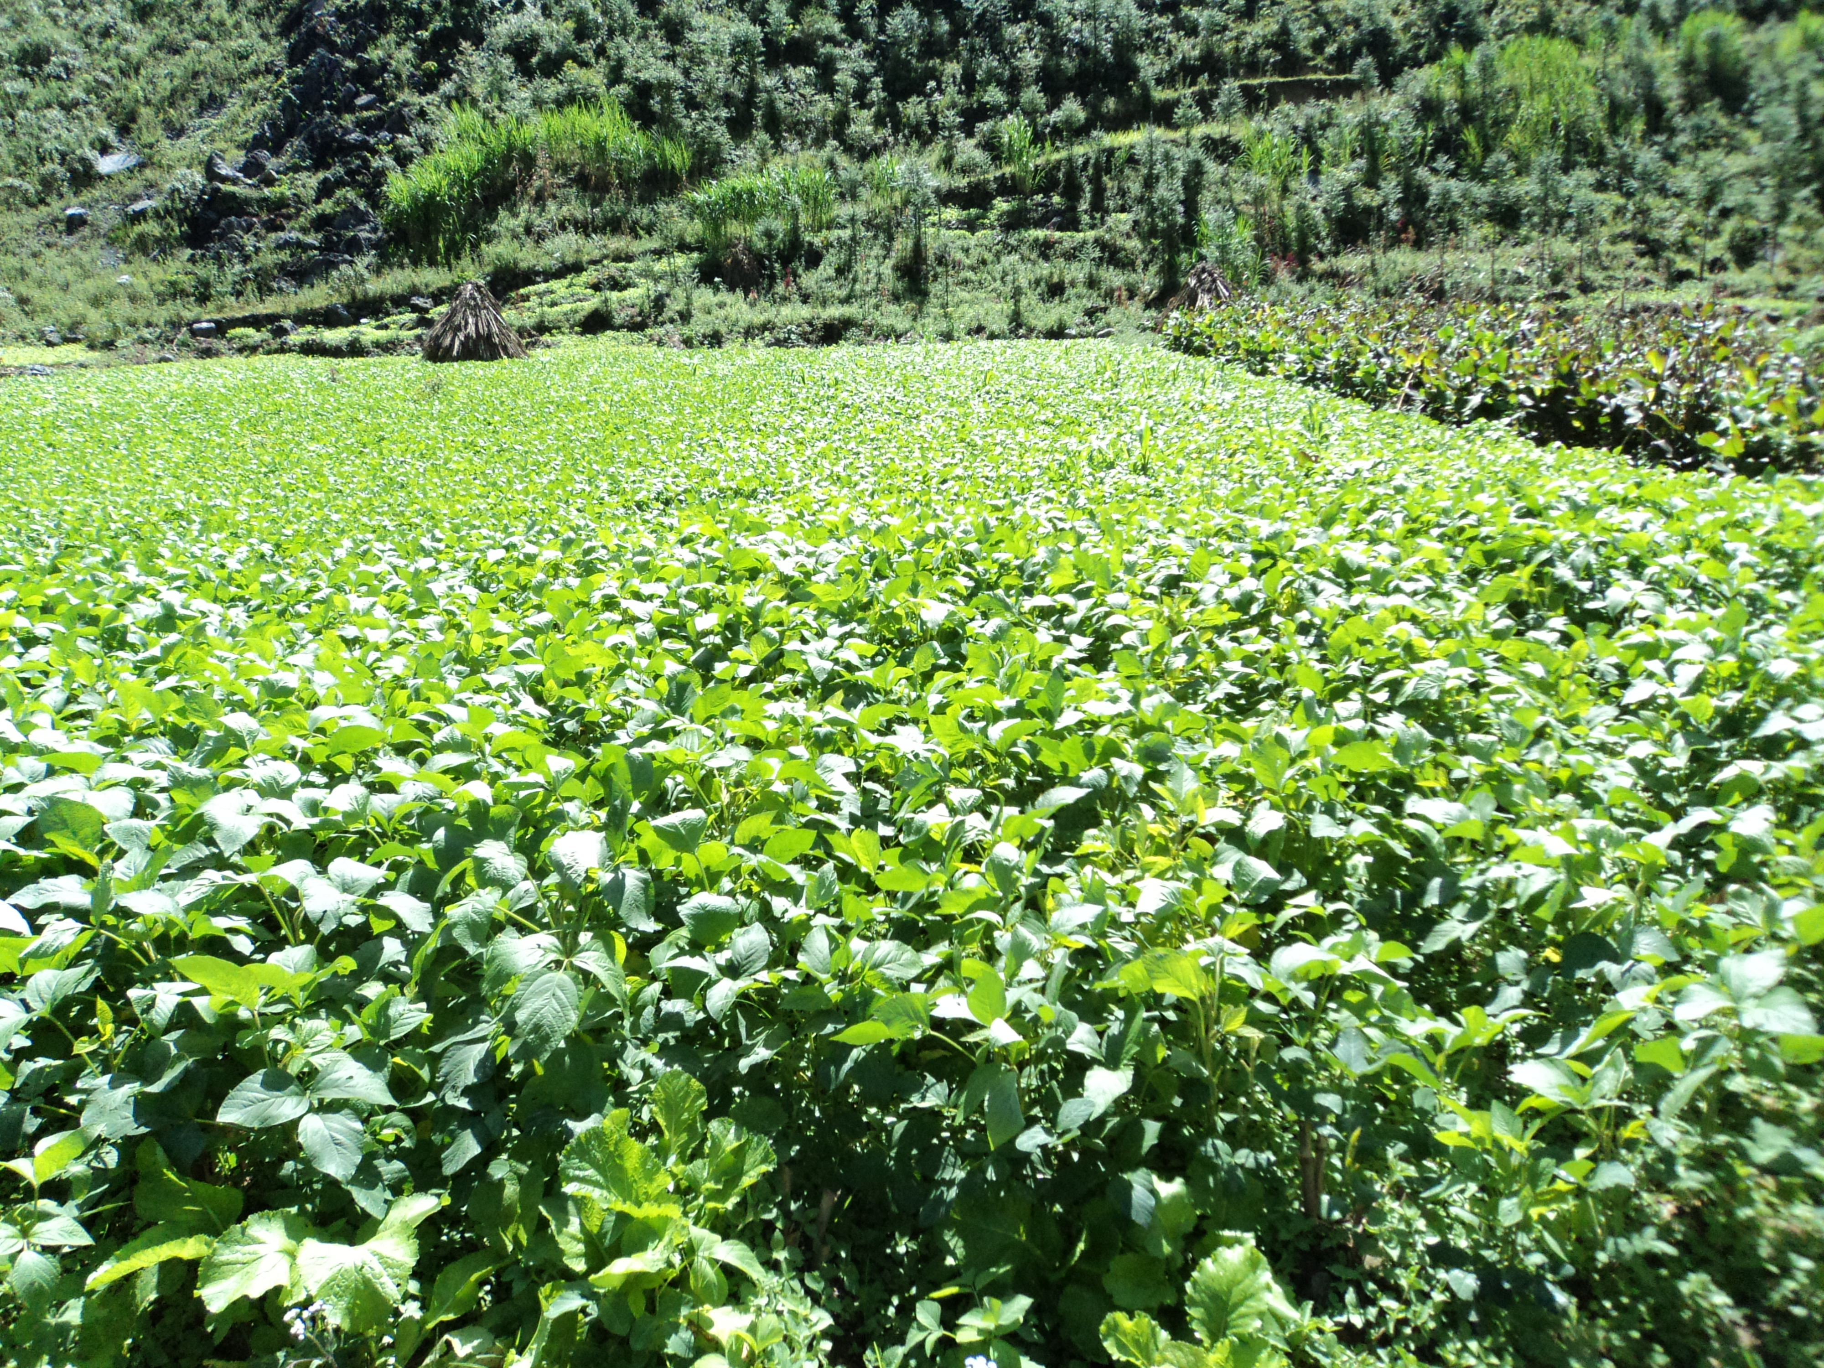

**Social and Economic Impact Assessment of the RCA Programme**

**Mutation Breeding Case Study**

Report Information

|  |  |
| --- | --- |
| Prepared for | International Atomic Energy Agency |
| Prepared by | Julian King, Kate McKegg, Andres Arau, Aaron Schiff, Martina Garcia Aisa |
| Cover image | DT2008 in Hà Giang, Viet Nam (courtesy Prof. Dr. Le Huy Ham) |
| Citation | King, J., McKegg, K., Arau, A., Schiff, A., Garcia Aisa, M. (2020). *Social and Economic Impact Assessment of the RCA Programme: Mutation Breeding Case Study.* Vienna, Austria: International Atomic Energy Agency. |

Disclaimer

Disclaimer: The information in this document is presented in good faith using the information available to us at the time of preparation. It is provided on the basis that the authors of the document are not liable to any person or organisation for any damage or loss which may occur in relation to taking or not taking action in respect of any information or advice within this document

Acknowledgements

The authors are grateful for the close and effective assistance of the Technical Cooperation Division for Asia-Pacific (TCAP) and Technical Cooperation Division of Programme Support and Coordination (TCPC) of the International Atomic Energy Agency (IAEA), and the experts from the 22 participating countries in the Mutation Breeding Regional Cooperative Agreement (RCA): Australia, Bangladesh, Cambodia, China, Fiji, India, Indonesia, Japan, Laos, Malaysia, Mongolia, Myanmar, Nepal, New Zealand, Pakistan, Palau, Philippines, Singapore, South Korea, Sri Lanka, Thailand, and Viet Nam. Their support and willingness to take part made this impact assessment possible.

Contents

Executive Summary 1

Introduction 2

Plant mutation breeding 2

Social and economic impact assessment methods 3

Social and economic impacts 4

Crop varieties developed through the mutation breeding RCA 4

Increased food production 5

Enhanced environmental protection 6

Strengthened regional capacity and capability 7

Economic impacts 7

Conclusion 8

Annex A: Mutation Breeding of Wheat in China under RCA – case example 10

Annex B: Mutation Breeding of Groundnut in India under RCA – case example 12

Annex C: Mutation Breeding of Sorghum in Indonesia under RCA – case example 15

Annex D: Mutation Breeding of Rice in Viet Nam under RCA – case example 19

Annex E: Survey Analysis 22

Annex F: Economic Analysis 41

Annex G: Methodology 58

Works cited 65

Tables

Table 1: Key evidence for criterion 1 22

Table 2: Number of mutant lines and mutant varieties developed under the mutant breeding RCA programme since 2000 (by country) 23

Table 3: Cumulative growing area and productivity of mutant crops (sorted by growing area) 26

Table 4: Key evidence for criterion 2 28

Table 5: Key evidence for criterion 3 33

Table 6: Year in which mutation breeding started at the national level, human resources, and facilities by country 33

Table 7: Mutant lines and mutant varieties developed (by country and crop) 40

Table 8: Crops with mutant varieties included in the economic analysis 42

Table 9: Summary of assumed benefits of mutant varieties attributed to the RCA 44

Table 10: Economic characteristics of crops used to estimate economic benefits of the RCA 46

Table 11: Costs incurred by the IAEA associated with RCA mutation breeding activities 50

Table 12: Opportunity cost of time assumptions for RCA member countries 52

Table 13: Summary of scenarios for key cost-benefit parameters 54

Table 14: Estimated economic benefits and costs attributable to the mutation breeding RCA for baseline parameter values 56

Table 15: Rubric (criteria and standards) for RCA mutation breeding projects 62

Figures

Figure 1: Mutant varieties developed under the RCA since 2000, by crop 4

Figure 2: Number of quality traits improved by mutant varieties 6

Figure 3: Map of the 22 countries that participate in the mutation breeding RCA programme 22

Figure 4: Mutant lines and mutant varieties developed by crop 24

Figure 5: Total mutant varieties developed by crop 24

Figure 6: Average change in yield productivity (tonnes/ha): mutant vs control 25

Figure 7: Total accumulated growing area of mutant crops since 2000 by country 25

Figure 8: Number of quality traits improved by mutant varieties 27

Figure 9: Proportion of responses reporting improvement in quality traits of mutant varieties 27

Figure 10: Proportion of responses reporting crops enhancing environmental protection 28

Figure 11: Reduction in the use of pesticide compared to control groups 29

Figure 12: Reduction in the use of chemical fertiliser compared to control crops 30

Figure 13: Increase in water efficiency compared to control crops 31

Figure 14: Increase in soil fertility compared to control crops 32

Figure 15: People trained in regional training courses under RCA by country 34

Figure 16: Number of experts that had joint missions to other countries under RCA 36

Figure 17: Number of publications since 2000 under RCA 37

Figure 18: Number of countries that have shared knowledge or services with other countries under RCA 38

Figure 19: Number of institutions and donors that have cooperated for mutation breeding by country 38

Figure 20: Assumed annual growing area of mutant varieties between 2000 and 2019 47

Figure 21: Estimated (undiscounted) benefits of mutant varieties relative to control varieties between 2000 and 2019 48

Figure 22: Annual number of mutation breeding activities facilitated by the IAEA 50

Figure 23: Annual number of people from RCA mutation breeding member countries who attended RCA mutation breeding activities organised by IAEA 51

Figure 24: Sensitivity of NPV estimates to changes in key parameters 56

Figure 25: Theory of change for RCA mutation breeding projects 61

# Executive Summary

The Regional Cooperative Agreement (RCA) for Research, Development and Training related to Nuclear Science and Technology for Asia and the Pacific will celebrate its 50th Anniversary in 2022. This report assesses the social and economic impacts of mutation breeding projects under the RCA and the value they have added over and above the primary research that has been undertaken by individual countries independently.

Plant mutation breeding involves exposing plant seeds, cuttings or tissue-culture material to radiation, such as gamma rays, and then planting the seed or cultivating the irradiated material to generate a plantlet. Plants are then multiplied and examined for new and useful traits – such as increased crop yields, improved nutritional quality, and reduced need for pesticide, fertilisers and irrigation.

This impact assessment was designed and undertaken by a team of external experts, in consultation with IAEA and RCA stakeholders.[1] It involved gathering evidence through an online questionnaire completed by 19 of the 22 participating Government Parties (GPs), analysis of IAEA administrative data, gathering information from mutation breeding experts at the IAEA and GPs, narrative success cases of mutation breeding from four GPs, and economic analysis of costs and benefits of mutation breeding research under the RCA. The assessment focuses on value added by the RCA, over and above the primary mutation breeding research that may be undertaken by countries individually.

The impact assessment found that the RCA has supported a significant body of mutation breeding research, including over 7,300 promising breeding lines with superior quality traits to previous crops, and 254 mutant varieties of crops certified and officially released. Key impacts of this research include increased food production, enhanced environmental protection, strengthened regional capacity and capability, and economic impacts. New mutant varieties have:

* Greater yield productivity, with a 32.7% increase in total production over their respective control crops
* Increased food supply, adding an extra 34.8 million tonnes of produce from 2000 to 2019
* Reduced use of agricultural inputs by 21% for chemical fertiliser, 17% for pesticides, 12% for irrigated water, and increased soil fertility by 8% (weighted averages by crop volumes 2000-2019)
* Higher market prices due to improved nutritional and environmental quality traits.

These impacts are not solely attributable to the RCA, but the RCA contributed significantly to the speed with which new mutant varieties have been developed and commercialised. In some cases, the RCA enabled mutant varieties to be developed that would not otherwise have been developed. The RCA supported enhanced national and regional capacity in mutation breeding research through networking and collaboration between countries and stakeholders, regional use of infrastructure, increased knowledge transfer between GPs and growing a critical mass of highly skilled researchers in the region. Feedback from many countries highlighted the importance of the RCA for building the skills and capacity of their mutation breeding teams.

Cost-benefit analysis estimated that the RCA created significantly more economic value than it consumed, with each 1 EUR of costs incurred between 2000 and 2019 associated with 11.1 EUR of economic benefits . Sensitivity analysis found that the net benefits attributable to the RCA remained positive under almost all alternative or pessimistic assumptions about benefits and costs, with a likely range of benefits between 5.8 EUR and 15.9 EUR per 1 EUR of costs. This suggests it is highly likely that the economic benefits of the RCA exceeded its costs.[2]

Pre-defined performance criteria were agreed with IAEA and GP experts to provide an evaluative framework for the impact assessment (Table 16, Annex G). On the basis of evidence provided by the IAEA and GPs, the RCA’s impacts meet standards for excellent performance on increased food production, good performance on enhanced environmental protection, excellent performance on strengthened regional capacity and sustainability, and excellent performance on economic value.

# Introduction

The International Atomic Energy Agency (IAEA) is the world’s central intergovernmental forum for scientific and technical co-operation in the nuclear field. Established in 1957, and headquartered in Vienna, Austria, the IAEA works for the safe, secure and peaceful uses of nuclear science and technology, contributing to international peace and security and the United Nations (UN) Sustainable Development Goals. The IAEA works in close partnership with Member States, UN agencies, research organisations and civil society to maximize the contribution of nuclear science and technology to the achievement of development priorities (“Atoms for Peace”).

The Regional Cooperative Agreement (RCA) for Research, Development and Training Related to Nuclear Science and Technology for Asia and the Pacific was established in 1972 and has enjoyed the benefit of the IAEA Technical Cooperation (TC) programme since. With the RCA due to celebrate its 50th Anniversary in 2022, it is timely to assess the social and economic impacts of the RCA programme supported under the IAEA TC programme.

The RCA has 22 participating Government Parties (GPs): Australia, Bangladesh, Cambodia, China, Fiji, India, Indonesia, Japan, Laos, Malaysia, Mongolia, Myanmar, Nepal, New Zealand, Pakistan, Palau, Philippines, Singapore, South Korea, Sri Lanka, Thailand, and Viet Nam.

At the 48th RCA General Conference Meeting in Vienna, Austria, 13 September 2019, the RCA endorsed the initiative to conduct social and economic impact assessment. To this end, the TC Division for Asia-Pacific (TCAP) and TC Division of Programme Support and Coordination (TCPC) jointly proposed to undertake case studies. A methodology was developed and was piloted to assess social and economic impacts of RCA mutation breeding projects. This report presents the findings from the pilot social and economic impact assessment.

## **Plant mutation breeding**

Plant mutation breeding is the process of exposing seeds, cuttings or tissue-culture material to radiation, such as gamma rays, and then planting the seed or cultivating the irradiated material in a sterile rooting medium, which generates a plantlet. The individual plants are then multiplied and examined for new and useful traits. Once the genetic changes giving rise to new traits have been identified, other biotechnological tools can be used to accelerate breeding of new varieties with desired traits. Plant mutation breeding does not involve gene modification, but rather uses a plant’s own genetic resources and mimics the natural process of spontaneous mutation. By using radiation, plant breeders can significantly enhance the genetic diversity necessary to develop new and improved varieties.

The overall objective of the RCA Mutation Breeding programme is to increase environmentally friendly crop productivity through the application of mutation techniques and related biotechnology, and enhanced capability of the RCA GPs in effective use of mutation techniques and biotechnology for the development of green crop varieties.

Characteristics of green crop varieties include:

* Minimized utilization of pesticide due to disease resistance
* Reduced application of inorganic fertiliser(s) due to highly efficient nutrition uptake
* Reduced use of irrigation due to drought tolerance
* Superior quality
* Increased crop yields.

## Social and economic impact assessment methods

The social and economic impact assessment methodology was developed specifically for the IAEA, in order to conduct impact assessments for case studies of TC projects under the RCA. The methodology follows the *Value for Investment* approach (King, 2017; King, 2019; King & OPM, 2018) and the Kinnect Group approach to evaluation rubrics (King et al., 2013; McKegg et al., 2018) – combining evidence from quantitative, qualitative and economic analysis, through the lens of an agreed performance framework, to evaluate the impact of mutation breeding projects under the RCA.

Social and economic impacts of the mutation breeding projects are diverse and include contributing to:

* Increased food availability, diversity and accessibility
* More nutritious food supply
* Increased incomes for farmers
* Reduced use of agricultural inputs
* Reduced environmental pollution
* Enhanced national capacities and capabilities in mutation breeding research, leveraged through regional collaboration
* Positive impacts for women and girls.

Some of these impacts can be evaluated using cost-benefit analysis. For example, increased farmers’ incomes and reduced use of agricultural inputs have a monetary value that is relatively simple to estimate. However, economic benefits are difficult to measure when mutant varieties are under development and have not yet entered into commercial production. Some new mutant varieties of crops have improved quality traits which have not yet translated into economic benefits. Moreover, some impacts, such as reduced environmental pollution, can be difficult to translate into monetary values. More complex still, impacts such as enhanced national capability and impacts for women and girls may be best understood by examining a range of evidence including ‘hard’ and ‘soft’ measures.

Accordingly, the mutation breeding case study uses a mix of methods, including:

* An online questionnaire deployed to all countries in the RCA and completed by 19 of the 22 GPs
* Analysis of administrative data on mutation breeding activity and costs, provided by IAEA
* Gathering additional information from mutation breeding experts at the IAEA and GPs
* Narrative case examples, written from details provided by four countries on a selection of ‘success cases’ of mutation breeding
* Economic analysis of costs and benefits of mutation breeding research under the RCA.

To combine the quantitative, qualitative and economic analysis, evaluation rubrics were developed. Rubrics, comprising a matrix of agreed criteria (aspects of performance) and standards (levels of performance) provided a transparent and robust framework for rating the social and economic impact of the mutation breeding projects under the RCA from the mix of evidence. Refer to Annex G for full details of the methodology.

# Social and economic impacts

Since 1972, the RCA has supported participating GPs in the Asia-Pacific region to undertake a considerable body of mutation breeding research. The following summary focuses on the most recent two decades, since the year 2000. It focuses on the value added by the RCA, over and above the primary research that may be undertaken by individual countries independently.

Key impacts of the mutation breeding projects under the RCA include contributions to increased food production, enhanced environmental protection, strengthened regional capacity and capability, and economic impacts. These impacts are summarised as follows.[3]

## Crop varieties developed through mutation breeding projects under the RCA

The RCA has supported a significant body of primary research. Since 2000, **7,316** *mutant lines* (breeding lines with the intended target traits) and **254** *mutant varieties* (certified and officially released) have been developed in the participating countries. These new mutant varieties span 12 different crops, with rice, wheat and soybean being the crops with the highest number of new mutant varieties (Figure 1).

Figure 1: Mutant varieties developed under the RCA since 2000, by crop

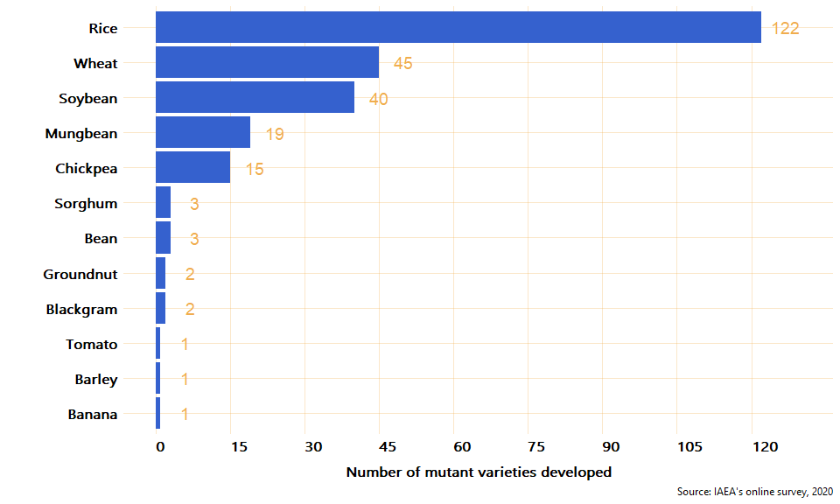

This level of research output is not solely attributable to the RCA, but the participating countries found that the RCA has made a significant contribution to the quantity, quality and pace of research. Based on information provided by experts in mutation breeding, the RCA enabled mutant varieties to be developed more quickly than they could otherwise have been developed (reported by 10 countries) and enabled mutant varieties to be developed that would not otherwise have been developed (reported by five countries).[4]

In Viet Nam, for example, cooperation under the RCA had several positive effects on the mutation breeding of rice, through improving the technology available for rice breeding which led to the introduction of new breeding techniques. Other positive contributions of RCA collaboration included improving the training of breeders and helping to increase awareness of rice mutation breeding among policymakers and breeders of other crops.

In some cases, the research would not have been possible without the RCA. For example, despite having no radiation or field facilities, Malaysia developed 16 mutant lines and one mutant variety by accessing irradiation facilities available through the RCA.

## Increased food production

The new mutant varieties, when adopted by farmers, produce greater crop yield, growing area and quality. Through these effects, the mutation breeding projects under the RCA contribute to increased food availability, diversity and accessibility, as well as increased incomes for farmers. These impacts contribute toward Sustainable Development Goals SDG 2 (Zero Hunger) and SDG 3 (Good Health and Wellbeing).

New mutant varieties have a greater yield productivity (tonnage of produce harvested per hectare) than their control crops. The new mutant varieties showed **32.7%** greater productivity overall than their controls, with the largest increases (50% or more) being for sorghum, groundnut, blackgram, and chickpea.

One example of the impact of increased yield productivity can be seen with Luyuan 502 in China. This wheat variety has been certified to have a grain yield that is 10.6% higher than the national control variety as well as being more tolerant to drought and key common diseases. For these reasons, between 2012 and 2018, the variety was planted on a total of 5.13 million hectares, becoming the second-most widely used wheat variety in China, increasing productivity by 3.89 million tonnes and generating an additional income of around EUR 1.1 billion to farmers.

The total cumulative growing area for the mutant crops is at least **39 million hectares** since 2000 – an area larger than Germany.[5] Taking into account the increased yield productivity and total cumulative growing area, the new mutant varieties under the RCA have collectively added an extra **34.8 million tonnes** of produce from 2000 to 2019.

Additionally, the mutant varieties have improved quality traits such as gluten-free, grain size, grain shape, grain color, milling quality, eating quality, mineral content, oil content, and seed protein content. These quality traits collectively improve the nutritional value and market prices of crops. Ten crops have improved at least one quality trait through mutation breeding under the RCA, and some have improved multiple traits (Figure 2).

Figure 2: Number of quality traits improved by mutant varieties

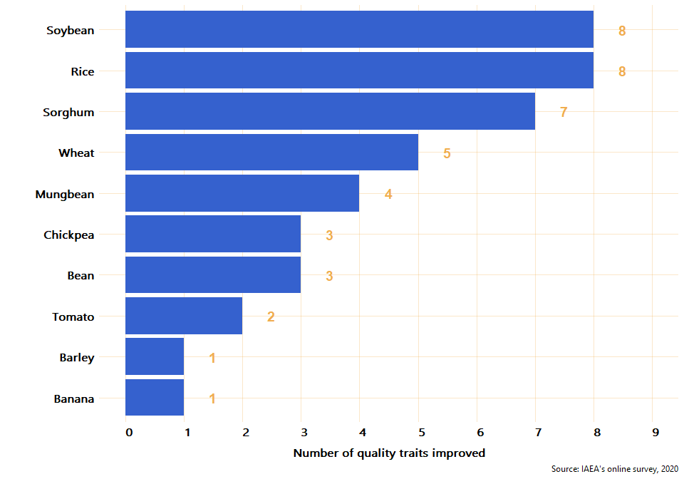

Market prices paid for produce from these new mutant varieties indicates there is demand for these varieties. The median price of mutant varieties was **5% higher** than control variety prices.

The case of sorghum in Indonesia provides a good example of the uptake of new mutant varieties. Three sorghum mutant varieties have been commercialised since sorghum became part of the RCA mutation breeding programme. As a country where the main staple food is rice and the population were not familiar with sorghum, commercialisation focused on highlighting the nutritional added value of the crop. Sorghum grains are high in fibre, iron, protein, calcium, and useful polyphenols, but low in fat and cholesterol. Furthermore, sorghum is gluten-free and has a low glycaemic index. Sorghum has become widely accepted in Indonesia. Sorghum products are now available in supermarkets, restaurants and bakeries in the country and are widely regarded as nutritious and tasty. Sorghum is showing significant potential for increasing Indonesia’s food security, improving farmers’ incomes and supporting more sustainable agricultural practice.

## Enhanced environmental protection

The new mutant varieties contribute to reducing the environmental footprint of agriculture by reducing the use of agricultural inputs (including pesticide, fertiliser and water) and by increasing soil fertility. These environmental impacts contribute to SDG 13 (Climate Action) and SDG 6 (Clean Water and Sanitation).

All of the 12 crops for which new mutant varieties were developed contribute to at least one environmental protection trait. On average, the mutant varieties overall reduced the use of:

* Chemical fertiliser by **21%** (rice, sorghum, soybean and wheat)
* Pesticides by **17%** (banana, barley, rice, sorghum, soybean, tomato and wheat)
* Water by **12%** (rice, sorghum, soybean and wheat).[6]

In the Philippines, for example, mutant banana and rice varieties have such effective resistance to pests and diseases that little or no pesticide is necessary. Some banana growers are using no pesticide at all while others are using insecticide and fungicide for post-tissue culture protection of plantlets being established in the nursery before planting out in the field. For rice, the Department of Agriculture is promoting organic agriculture and encourages growers to minimize using pesticides. Instead, integrated pest management is promoted, with pesticide used as the last resort.

Additionally, six mutant varieties (bean, chickpea, mungbean, rice, sorghum and soybean) increased soil fertility in comparison to control crops, by an average **8%**.

## Strengthened regional capacity and capability

Regional collaboration through the RCA supports enhanced national and regional capacity in mutation breeding research, contributing to SDG 17 (Partnerships for the Goals). In particular, the RCA supports:

* Networking and collaboration between countries and stakeholders
* Regional use of infrastructure
* Increased knowledge transfer between government parties
* Growing a critical mass of highly skilled researchers in the region.

Since 2000, highlights of the collaboration under the RCA include:

* Training **470** individuals (including **108** women) in **19** countries, through national and regional training courses
* **26** expert missions where experts from six countries (China, Australia, Philippines, Pakistan, Myanmar, and India) provided experts to share knowledge with other countries in the RCA
* **23** meetings/workshops for **453** senior members in mutation breeding research teams, contributing to knowledge sharing and human resource development across the region
* **13** countries providing mutation breeding services and knowledge to other RCA countries through other methods such as data, events, funding, infrastructure, jobs, projects, publications, research, skills shares, and tools
* **1,801** publications of which over half were scientific publications
* **353** companies/institutions cooperated with partner countries in the dissemination of mutant varieties
* **85** donors provided funding towards mutation breeding research.

Feedback from the countries highlighted the importance of the RCA for building the skills and capacity of their mutation breeding teams, as detailed in case examples and survey results.

In India, for example, the knowledge and experience gained under the RCA programme has been incorporated in the pre-existing national mutation breeding research on groundnut, particularly for biotic and abiotic stress tolerance. Additionally, since groundnut research became part of the RCA, national scientists have benefited from ground-breaking knowledge sharing and capacity building events. Indeed, the RCA has provided exposure to innovative mutation research areas such as identification of molecular markers, linkage of markers to traits of interest, marker assisted breeding, Quantitative Trait Locus (QTL) mapping, molecular and nutrient analysis, and new screening techniques for biotic and abiotic stress tolerance, among others. The RCA has also provided training on specific statistical software packages.

## Economic impacts

A social cost-benefit analysis was conducted to estimate economic impacts generated by the RCA. The analysis estimated the incremental (additional) costs and benefits that are attributable to RCA collaboration in mutation breeding – i.e. it did not estimate the benefits and costs of mutation breeding activities as a whole but rather the benefits and costs associated with collaboration under the RCA, compared to a hypothetical situation with no RCA.

The analysis used data from the survey, together with administrative and cost data provided by the IAEA. It estimated the costs and benefits that occurred between 2000 to 2019, as well as projections of future benefits from 2020 onwards that are associated with ongoing production of mutant varieties of crops that were developed under the RCA between 2000-2019. Costs and benefits were analysed as annual time series and adjusted for timing, using discounting to convert values occurring at different points in time into present values. Two different discount rates were used, depending on whether benefits and costs occurred in the past (between 2000 and 2019) or in the future (2020 onwards).

**Benefits** represent the RCA’s contribution to economic value through mutation breeding. The main way that the RCA generated economic benefits was by speeding up the mutation breeding process from variety selection to production and commercialisation of successful mutant varieties. The RCA also helped several countries to develop mutant varieties that they would not otherwise have developed in the absence of the RCA, but these crops are recently commercialised so the associated economic benefits to date are relatively small. Survey data revealed a total of 20 crops where the RCA contributed in one of these two ways. These crops had various superior characteristics (compared to a non-mutant control variety) that generated economic benefits through some or all of:

* Increased crop yield
* Increased market price
* Changes in costs of production associated with use of chemical fertilisers and pesticides.

**Costs** represent the opportunity costs arising from committing resources of the IAEA and GPs to RCA-related activities. They include costs of conducting RCA mutation breeding training courses, workshops, expert meetings and other activities, costs associated with developing additional mutant varieties of crops (where attributable to the RCA), and overhead costs.

**Results** of the analysis indicate that the RCA delivered excellent economic outcomes, with estimated benefits significantly exceeding estimated costs. In the baseline scenario, the RCA generated **EUR 15.8m of net economic benefits** (valued in 2020 EUR, including 1.6m costs and 17.3m benefits). As is often the case in cost-benefit analysis, some important parameters required modelling assumptions to be developed, in consultation with mutation breeding experts. To understand the implications of uncertainty in these modelling assumptions, sensitivity analysis was conducted that involved testing how the estimates of benefits and costs varied under alternative assumptions. Sensitivity analysis revealed that under a range of alternative conservative and optimistic assumptions, **net benefits could be between EUR 7.5m and EUR 23.2m**. In our view, it is likely that the net benefits of the RCA remain positive under almost all plausible assumptions about benefits and costs.

This implies that, historically, **each 1 EUR of costs was associated with 11.1 EUR of economic benefits on average with a range from 5.8 EUR under the most pessimistic scenario that we considered to 15.9 EUR under the most optimistic scenario that we considered**.

Our estimates of costs and benefits are largely retrospective and are based on actual outcomes under the RCA between 2000 and 2019. These results should not be used to make decisions about the future of the RCA, or to decide whether the scale of the RCA should be increased or decreased. Full details of the cost-benefit analysis are provided in Annex F.

## Conclusion

The RCA has supported a significant body of mutation breeding research, contributing to the speed with which these mutant varieties have been developed, distributed for production and commercialised and, in some cases, enabling mutant varieties to be developed that would not otherwise have been developed. This research has brought positive impacts including increases in yield productivity and food supply, reduced use of agricultural inputs, and increased market prices for produce.

Cost-benefit analysis estimated that the RCA created significantly more economic value than it consumed between 2000 and 2019, with each 1 EUR of costs incurred between 2000 and 2019 associated with 11.1 EUR of economic benefits on average.

Pre-defined performance criteria were agreed with IAEA and GP experts to provide an evaluative framework for the impact assessment (Table 16, Annex G). Evidence of RCA impacts provided by the IAEA and GPs suggests that the RCA meets standards of:

* **Excellent** performance for **increased food production**, with new varieties of crops contributing to a 32.7% increase in overall productivity and improving multiple quality traits
* **Good** performance for **enhanced environmental protection**, with substantial reductions in the use of agricultural inputs (meeting thresholds for excellent on pesticide use and good on fertiliser and water use)
* **Excellent** performance for **strengthened regional capacity and sustainability** through networking and collaboration between countries and stakeholders, regional use of infrastructure, increased knowledge transfer between government parties and growing a critical mass of highly skilled researchers in the region
* **Excellent** performance for **economic value**, with cost-benefit analysis suggesting with a high level of certainty that the net benefits of the RCA were positive under almost all plausible assumptions about benefits and costs.

Overall, when assessed against the agreed performance framework, the RCA’s contribution to mutation breeding projects demonstrates an excellent level of social and economic impact.

# Annex A: Mutation Breeding of Wheat in China under RCA – case example

### Background

China started its mutation breeding programme in 1957, and as one of the most important staple food crops, wheat was included into the research programme. Nevertheless, it was not until 2002 that wheat became part of the mutation breeding programme under the Regional Cooperative Agreement for Research, Development and Training Related to Nuclear Science and Technology for Asia and the Pacific (RCA).

Since 2002, wheat mutation breeding research under the RCA has led to the identification of more than 5000 advanced mutant lines and the development of 42 mutant varieties in the country[7]. One of the mutant varieties (Luyuan 502) is nowadays the second most widely used wheat mutant variety in the country.

In the last twenty years, research undertaken under the RCA has resulted in a considerable increase in the commercialisation of wheat in the country. Prior to the 2000s, there was barely any commercialisation of wheat; farmers used to keep the seeds for themselves and sow them for their next harvest. Furthermore, mutant varieties of wheat have yields that is, on average, 30% higher than from the varieties where they originated. This higher yield has been a contributing factor for the overall increase experienced by wheat productivity over the last two decades: from 3.78 tonnes/ha in 2000 to almost 6 tonnes/ha in 2019.

### Production and Commercialisation

The main institution responsible for the use of nuclear techniques for the production and commercialisation of agriculture crops is the Chinese Academy of Agricultural Sciences (CAAS). Other provincial academies of agricultural sciences such as the Shandong or Heilongjiang Academy of Agricultural Sciences (SAAS and HAAS, respectively) also play an important role as well.

### Economic, Social, and Environmental Effects

With 19% of the world’s population but only 7% of its arable land, food security lies at the core of China’s socioeconomic policymaking. Given this context, research on mutation breeding in wheat has focused on the improvement of agronomic traits of the new crop varieties. Mutant varieties of wheat have proven to be more tolerant to drought, lodging, and salt, as well as less prone to diseases, suggesting that they have large potential for environmentally sustainable increase in crop productivity and promoting economic growth among farmers.

A classical example is Luyuan 502 mutant, which is the second most widely used wheat variety in China in 2018. This variety was developed and nationally released by CAAS and SAAS in 2011 through space mutagenesis and cross breeding. It has been certified to have grain yield advantage of 10.6% higher than the national control variety and also has higher drought tolerant capacity and tolerance to other key diseases. Between 2012 and 2018, this variety was planted on a total of 5.13 million hectares, increasing productivity by 3.89 million tonnes and generating an additional income of about USD1.31 billion to farmers.

|  |
| --- |
|  |
| *Luyuan 502.* |

In addition, this mutant variety of wheat also has several environmental benefits including having high levels of tolerance to drought, making it water efficient. It is also resistant to major diseases, hence requires less fertiliser and pesticide use. It has been estimated that use of fertiliser and pesticides can be significantly reduced in wheat production, by as much as 15 and 30 percent, respectively.

### RCA Contribution

Since 2002, the RCA mutation breeding programme has been supporting capacity building for the country’s wheat mutation breeding programme. National researchers have had the opportunity to take part in regional training courses, as well as other knowledge-exchange events. The key training area that the RCA has contributed to is the wide and effective application of induced mutations and, in particular, the use of new mutagenesis technology. Junior scientists have especially benefited from these training and knowledge-exchange opportunities. Consequently, the number of young researchers working on wheat mutation breeding has increased considerably in the last two decades, by up to 50 .

The number of scientific articles on wheat mutation breeding under the IAEA/RCA projects has also increased considerably, mainly due to the engagement with the Asia and Oceania Association of Plant Mutagenesis (AOAPM).

# Annex B: Mutation Breeding of Groundnut in India under RCA – case example

### Background

India started its mutation breeding programme in 1960, and as one of the most important oilseed crops, groundnut was included into the research programme. In 1972, India became part of the mutation breeding programme under the Regional Cooperative Agreement for Research, Development and Training Related to Nuclear Science and Technology for Asia and the Pacific (RCA). Nevertheless, it was not until 2000 that groundnut was included into the RCA mutation breeding programme.

Groundnut and other oilseed crops have been at the core of national mutation breeding programmes since the beginning, as they are key food components in India and a large proportion of the population rely on them as a source of dietary oils and proteins. It is estimated that oilseeds constitute about 12% of the total food grain production in the country, and national groundnut production accounts for almost a sixth of the total world production. The main objective of mutation breeding in groundnut, which was initiated at the Bhabha Atomic Research Centre (BARC) in Mumbai, was to generate variability in characters contributing to economic yield.

To date, 15 mutant varieties of groundnut have been successfully developed by several public institutions. Seven of these varieties were developed by BARC. Mutation breeding of groundnut has resulted in a number of high-yielding, stress-tolerant varieties, with improved oil content.

### Production and Commercialisation

Over 20 public institutions are currently engaged in the production and commercialization of groundnut varieties. Some of the most important institutions are BARC, the Indian Council of Agricultural Research, state agricultural universities and departments, and national and state seed corporations, among others.

Production and commercialization of successful varieties of groundnut follows the same process designed by the Government of India. The process consists of 7 different phases: i) induction of mutant or hybridization of desirable parent(s), ii) selection and stabilisation of desirable mutants or recombinants, iii) evaluation at the institutional level to confirm improved traits, iv) evaluation at state or national breeding trials to establish superiority over the existing varieties by testing across locations and seasons, v) large-scale evaluation at adaptive trials on farmers’ fields, vi) recommendation by the scientific committee for a given agroclimatic region and season, and vii) release and notification of the new variety for commercial cultivation by the Government of India.

|  |
| --- |
|  |
| *Farmer's field view of Trombay groundnut variety, TG 39.* |

### Economic, Social, and Environmental Effects

Mutant varieties of groundnut have proven to bring a series of economic advantages compared with the traditional varieties, even though they are not a major share of the production and commercialisation of groundnut in the country.

Mutant varieties of groundnut have proven to have a yield that is, on average, 50% higher than from the varieties where they originated: 3 tonnes/ha for mutant varieties, compared with 2 tonnes/ha for non-mutant varieties. This increased productivity is likely to raise farmers’ income by 10 to 20%. It has been demonstrated that by cultivating these mutant varieties, the groundnut productivity in major groundnut states like Gujarat, Andhra Pradesh, Maharashtra, Karnataka, Orissa and Rajasthan has been almost doubled, and hundreds of farmers significantly improved their net profit up to 1,200 US dollars/ha.[8]

Some mutant varieties of groundnut also have a shorter maturity period. For example, the release of the large seed mutant variety TPG-41 benefited many farmers, traders, and exporters by virtue of its earliness, moderate seed dormancy and superior productivity. Some other mutant varieties of groundnut also have environmental benefits, since they are more drought tolerant and therefore water efficient. For example, the drought tolerant variety TG 37A has rekindled groundnut cultivation in desert areas of Rajasthan state.

|  |
| --- |
|  |
| *Farm woman with harvest of Trombay groundnut variety, TG 51.* |

### RCA Contribution

The knowledge and experience gained under the RCA programme have been incorporated in the pre-existing national mutation breeding research on groundnut, particularly for biotic and abiotic stress tolerance.

Additionally, since groundnut research became part of the RCA, national scientists have benefited from ground-breaking knowledge-sharing and capacity building events. Indeed, RCA has provided exposure to innovative mutation research areas such as: identification of molecular markers, linkage of markers to traits of interest, marker assisted breeding, Quantitative Trait Locus (QTL) mapping, molecular and nutrient analysis, and new screening techniques for biotic and abiotic stress tolerance, among others. RCA has also provided training on specific statistical software packages.

# Annex C: Mutation Breeding of Sorghum in Indonesia under RCA – case example

### Background

The Regional Cooperative Agreement for Research, Development and Training related to Nuclear Science and Technology for Asia and the Pacific (RCA) was first established in 1972 with six participating countries, including Indonesia[9]. In that same year Indonesia began its mutation breeding programme, although it did not include sorghum at the time.

Twenty years later, Indonesia’s National Nuclear Energy Agency (BATAN) began its sorghum research as part of the mutation breeding program. The main objectives were to improve the quality and productivity of the grain. At the time, traditional sorghum varieties (Keris, Mandau, Sangkur, among others) were mainly grown by small-scale farmers and used as animal feed. Although it was never a major crop, its ability to grow well in poor soils of drought-prone areas made the crop particularly appealing for subsistent farmers.

In 2005 sorghum became part of the RCA mutation breeding programme[10]. Sorghum research has focused on three different types of sorghum: i) grain sorghum, where the grain is used for food, ii) forage sorghum, where the grain and biomass are used for animal feed, and iii) sweet sorghum, where the stem juice is used for producing liquid sugar and/or further processed for the production of bioethanol (as bioenergy).

Since 2005, sorghum selection and screening work has led to the identification of 15 promising advanced mutant lines to be included in multi locations trials. Three sorghum mutant varieties have since been developed: Pahat, Samurai-1 and Samurai-2. The first mutant variety was released by the Ministry of Agriculture in 2013, while the other two were released in 2014. Commercialisation of these varieties began in 2017[11].

|  |
| --- |
|  |
| *IAEA/RCA training course on sorghum mutation breeding at BATAN, Indonesia.* |

This work has resulted in sorghum becoming widely accepted in Indonesia. While it had initially very limited acceptance by farmers and consumers or market presence, sorghum is now no longer regarded a minor crop. Sorghum products are now available in supermarkets, restaurants and bakeries in the country, and in general, are widely accepted as being nutritious and tasty. Sorghum is now showing significant potential for increasing Indonesia’s food security, improving farmer incomes as well as supporting more sustainable agricultural practice.

### Production and Commercialisation

Sorghum seeds are supplied by BATAN to commercial producers in Indonesia, and these are commercially produced, labelled, and distributed to farmers. Once harvested, farmers sell sorghum grains back to the company, and these grains are used to generate commercial sorghum products such as sorghum sugar, sorghum nectar, brown and white sorghum rice, and sorghum cookies, among others.

|  |
| --- |
|  |
| *Some commercial sorghum products sold in market in Indonesia.* |

### Economic, Social, and Environmental Effects

In a country where the main staple food is rice and the population had not been familiar with this new crop, commercialisation of sorghum focused on highlighting the nutritional added value of the crop. Sorghum grains are high in fibre, iron, protein, calcium, and useful polyphenols, but low in fat and cholesterol. Furthermore, sorghum is gluten free and has a low glycaemic index, so it is particularly suitable for people suffering from diabetes and related diseases.

|  |
| --- |
|  |
| *Indonesian traditional food “Tumpeng” made from sorghum grains.* |

Apart from its nutritional value, the mutant varieties of sorghum have proven to be early maturing, high yielding, and drought tolerant, making them ideal for dry-season cultivation. This means that they have a large potential to increase marginal land productivity and promote economic growth, particularly in those drought prone areas where arable lands are fallow and cannot grow other types of food crops (such as those mostly found in the eastern part of Indonesia). Indeed, sorghum mutant varieties have been certified by the Ministry of Agriculture to have a grain yield around 50% larger than the non-mutant varieties. This characteristic, together with the possibility of growing and selling sorghum during the dry season, has the potential to lead to an average increase in farmers’ income of between 20% and 30%.

In addition to their potential for boosting economic development due to their agronomic traits, these new varieties of sorghum hold promise for supporting the country’s efforts to reduce its dependence on rice, ensuring increased future food security[12].

The mutant varieties of sorghum also have several environmental benefits. They are drought tolerant and therefore water efficient. They are also resistant to major diseases, so require less fertiliser and pesticide use. It is estimated that use of irrigation and pesticides can be significantly reduced in sorghum production, by as much as 20 percent. Furthermore, sorghum is highly efficient in its photosynthetic rate. This means it produces larger amounts of biomass which can be recycled into the soil, helping to maintain soil fertility supporting more sustainable agricultural practice. Sorghum stovers (stem and leaves) can also be used for feeding animals (ruminants).

|  |
| --- |
|  |
| *New dwarf and early maturing sorghum mutants at BATAN, Indonesia.* |

### RCA Contribution

Since 2005, when sorghum first became part of the RCA mutation breeding programme, five projects have been implemented as part of the IAEA/RCA. These projects have supported capacity building for the country’s sorghum mutation breeding programme. Senior researchers have participated in scientific knowledge exchange meetings, while more junior scientists have benefited from participation in regional training. Under RCA collaboration Indonesia has itself hosted some of these scientific capacity building activities, for example, training on mutant screening for abiotic stresses and molecular approaches for selection of desired green traits in crops.

In addition to capacity building activities, Indonesia has also published scientific articles on sorghum mutation breeding[13] under the IAEA/RCA projects.

The RCA has also supported Indonesia’s research programme to qualify products to meet market standards in Indonesia.

The success of the sorghum mutation breeding research has also been acknowledged through the Food and Agriculture Innovation Award of the Ministry of Agriculture in 2015, and the Agricultural Development Award from the President of Indonesia in 2016.

# Annex D: Mutation Breeding of Rice in Viet Nam under RCA – case example

### Background

Viet Nam started its mutation breeding programme in the late 1970s. Then in 1984 it established a mutation breeding division within the Centre for Agricultural Genetics, where mutation breeding was adopted as one of the core strategies for crop breeding in the country. Sixteen years later, in 2000, the country joined the mutation breeding programme under the Regional Cooperative Agreement for Research, Development and Training Related to Nuclear Science and Technology for Asia and the Pacific (RCA).

Rice has been at the centre of the country’s mutation breeding programme because it is the main staple crop in Viet Nam, contributing more than 90% to food security. Indeed, after the war ended in 1975, the government invested considerable resources into rice breeding in order to make the country self-sufficient in rice supply.

Since 2000, collaboration under RCA has led to the release and registration of 30 mutant varieties of rice across a series of institutions including the Agricultural Genetics Institute (AGI), the Food Crop Research Institute (FCRI), and the Institute of Agriculture in the South (IAS), among others[14].

Although nowadays the major share of production and commercialisation of rice in the country is still non-mutant[15], collaboration under RCA has played an important role in raising awareness around the potential of rice mutation breeding for crop improvement among policymakers and breeders of other crops. This has been of key importance given the country’s context of decentralized production and commercialisation of mutant crop varieties, which has often led to a lack of governmental support and related funding.

### Production and Commercialisation

Unlike other countries, Viet Nam does not have a unique mutation breeding programme centralised under one particular institution; rather several organisations are in charge of running their own parallel mutation breeding programmes. This situation results in a generalized lack of funding for the implementation of mutation breeding programmes, which constitutes a challenge for the successful production and commercialisation of mutant crop varieties.

### Economic, Social, and Environmental Effects

Mutant varieties of rice have proven to bring a series of economic advantages with respect to the traditional varieties, even though they are not a major share of the production and commercialisation of rice in the country.

Mutant varieties of rice have proven to have a yield that is, on average, 8% higher than from varieties from where they originated. It is estimated that between 2000 and 2019, the 30 mutant varieties of rice, cultivated on a total of 2,234,530 hectares across the country, increased rice yield harvest by 1.1 million tonnes. This increase in yield translated into 480 million USD, which benefited 1,694,780 farmers across the country.

Released mutant varieties of rice also have a shorter maturity period, are more tolerant to lodging and salt, and less prone to major diseases. For example, mutant rice variety VND99-3, registered as a national variety with quality for export, has a maturity period of 100 days, meaning three rice harvests per year in the Mekong Delta. This means that mutant varieties have a large potential to increase marginal land productivity and promote economic growth among farmers.

|  |
| --- |
|  |
| *One of the mutant varieties of rice (Lam Son 10) in Viet Nam.* |

### RCA Contribution

Cooperation under the RCA had a positive effect on the technology available for rice breeding, which led to an improvement in effectiveness and efficiency in breeding. Indeed, through capacity building activities and knowledge-exchange events, young national scientists have been introduced to new methods of irradiation, new techniques of selection, and innovative testing and evaluation methodologies, which had a positive impact on their breeding research. These training activities have also led to improved communication and cooperation among young rice breeders across regions.

Furthermore, collaboration under RCA has considerably increased awareness about the potential of mutation breeding for crop improvement among policymakers and breeders of other crops, which has been of particular importance given the decentralisation of mutation breeding research across institutions in the country.

The success of the rice mutation breeding research has also been acknowledged through different high awards in national agriculture exhibitions. For example, the 2005 Viet Nam National Prize for Science and Technology was awarded to the mutant rice variety VND95-20. Given its high quality and tolerance to salinity, this variety became the key rice variety for export in that year.

|  |
| --- |
|  |
| *High quality rice mutants received high awards in national agriculture exhibition in Viet Nam.* |

# Annex E: Survey Analysis

## Introduction

This analysis includes information of the 22 countries that are part of the Regional Cooperative Agreement for Research (RCA): Australia, Bangladesh, Cambodia, China, Fiji, India, Indonesia, Japan, Laos, Malaysia, Mongolia, Myanmar, Nepal, New Zealand, Pakistan, Palau, Philippines, Singapore, South Korea, Sri Lanka, Thailand, and Viet Nam. The findings presented in this report include analysis of internal data provided by IAEA and information provided by national experts through the implementation of an online survey conducted between February to April, 2020. From the total 22 countries, 19 participated in the online survey. The three countries that did not take part on the online survey were Fiji, New Zealand, and Singapore

The map below shows all the countries that are part of this study.

Figure 3: Map of the 22 countries that participate in mutation breeding projects under the RCA programme

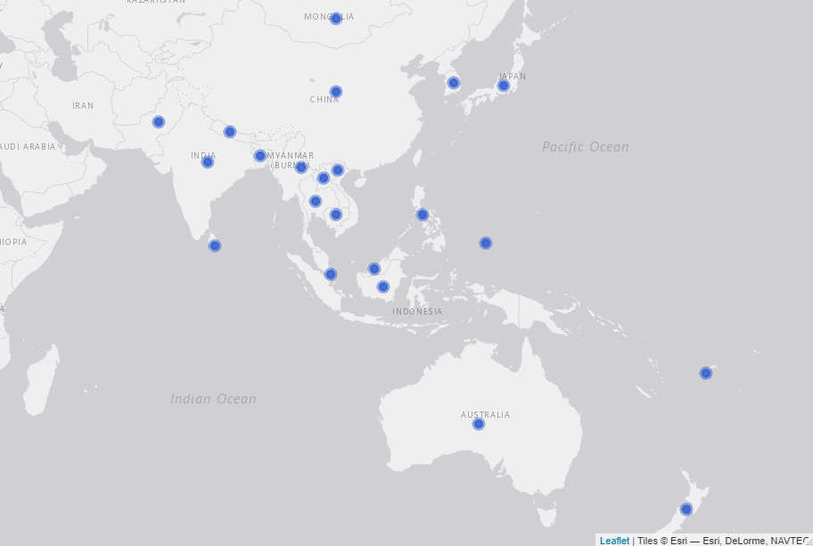

## Criterion 1: Increased food production

Table 1: Key evidence for criterion 1

|  |  |  |
| --- | --- | --- |
| Evidence | Finding | Source |
| Total number of new mutant lines | 7,316 | Online survey |
| Total number of new mutant varieties | 254 | Online survey |
| Average yield increase (% increase in tonnes/Ha) | 32.7% | Online survey |
| Total accumulated growing area (in thousand Ha) since 2000 | 38,826 | Online survey |
| % of new mutant varieties that improve quality traits | 100% | Online survey |

### Mutant lines and mutant varieties developed under RCA since 2000

The definition used by this report for mutant lines and mutant varieties is the following: **mutant lines** are what are also called breeding lines. They don’t have a commercial name yet but may have qualified for the target trait that it is been bred for (mostly with breeders to be released later). They have not yet been officially released while **mutant varieties** are those which have a name (example Bamati or NERICA rice, ug 99 for wheat blast etc). These have been certified and officially released, and their passport data is in the public domain.

According to the responses from the online survey, **7,316 mutant lines and 254 mutant varieties have been developed under RCA since 2000**. As shown in Table 2 below, from the 19 countries that participated in the online survey, two have not developed a mutant line under RCA - Bangladesh and Palau - and five have not developed a mutant variety yet - Bangladesh, Cambodia, Laos, Nepal, and Palau. Thus, from all the countries that participated in the online survey 11% have not developed a mutation line and 26% have not developed a mutation variety yet. The countries that have developed more mutant varieties under the RCA programme are Japan (60), China (42), Indonesia (40), Viet Nam (36), and Pakistan (35). Refer to Table 7 at the end of this annex to see all the mutant lines and mutant varieties reported by country and crop.

### Qualitative case from Malaysia:

Malaysia is an interesting case because although they do not have radiation nor field facilities, they have developed 16 mutant lines and 1 mutant variety. This is possible because according to an internal informant from IAEA, "One of the recommendations of the RCA, is that participating countries not having an irradiation facility in their country are encouraged to use the irradiation service of the FAO/IAEA Plant Breeding and Genetics Laboratory in Seibersdorf, Austria, or arrange irradiation of their material in one of the projects participating countries having such facilities. Moreover, countries such as China, Indonesia, Japan and Vietnam are some of the countries that share their facilities with other participating countries without the facility"

Table 2: Number of mutant lines and mutant varieties developed under the mutant breeding RCA programme since 2000 (by country)

|  |  |  |  |  |
| --- | --- | --- | --- | --- |
| Country | Has developed lines | Lines developed | Has developed varieties | Varieties developed |
| Australia | Yes | 150 | Yes | 1 |
| Bangladesh | No | 0 | No | 0 |
| Cambodia | Yes | 1 | No | 0 |
| China | Yes | 5000 | Yes | 42 |
| India | Yes | 65 | Yes | 7 |
| Indonesia | Yes | 450 | Yes | 40 |
| Japan | Yes | 60 | Yes | 60 |
| Laos | Yes | 93 | No | 0 |
| Malaysia | Yes | 16 | Yes | 1 |
| Mongolia | Yes | 20 | Yes | 3 |
| Myanmar | Yes | 35 | Yes | 5 |
| Nepal | Yes | 50 | No | 0 |
| Pakistan | Yes | 173 | Yes | 35 |
| Palau | No | 0 | No | 0 |
| Philippines | Yes | 34 | Yes | 7 |
| South Korea | Yes | 800 | Yes | 7 |
| Sri Lanka | Yes | 19 | Yes | 1 |
| Thailand | Yes | 100 | Yes | 9 |
| Viet Nam | Yes | 250 | Yes | 36 |

*Source: IAEA’s online survey, 2020*

The figure below shows the number of mutant lines and mutant varieties developed by crop. Thus, as the table shows, more than 900 mutant lines of rice have been developed in order to produce about 120 mutant varieties of this crop; there have been more than 5,000 mutant lines of wheat to develop 45 mutant varieties. In the case of soybean, 347 mutant lines and 45 mutant varieties having developed under RCA since 2000 (Figure 4).

Figure 4: Mutant lines and mutant varieties developed by crop

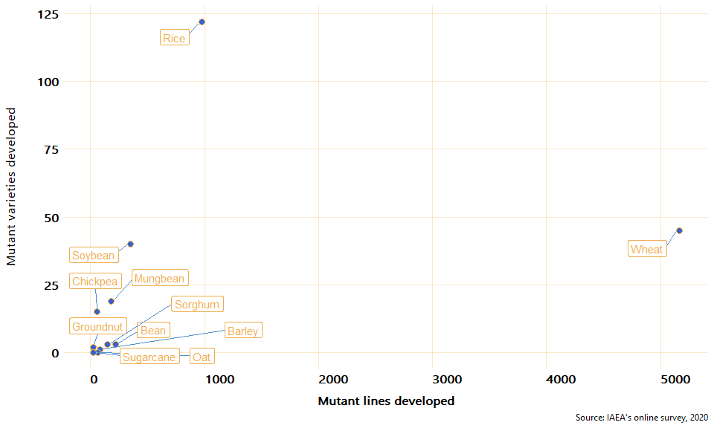

From the 254 mutant varieties developed under RCA since 2000, 145 are rice varieties, 45 wheat, and 40 soybean. Figure 5 presents the total number of mutant varieties developed by crop since 2000.

Figure 5: Total mutant varieties developed by crop



### Productivity

To estimate the impact that mutant varieties have on productivity, the online survey asked the experts to report on the average yield productivity (in tonnes/ha) for the mutant and the control crops respectively. According to the responses of the experts, all the mutant varieties have a higher yield productivity than their control crops. On average, the mutant varieties have 32.7% higher productivity compared to the control crops. From all the reported mutant varieties crops, Sorghum shows the highest increase compared to its control crop (52.5%), followed by groundnut, blackgram, and chickpea with a 50% increase in yield productivity.

Figure 6 shows the average change in productivity between mutant and control crops.

*Note the graph below excludes tomato and banana because they have a much higher yield than the rest and including them would affect the visualization, they increased their yield 16.6% and 33.3% respectively*[16]

Figure 6: Average change in yield productivity (tonnes/ha): mutant vs control

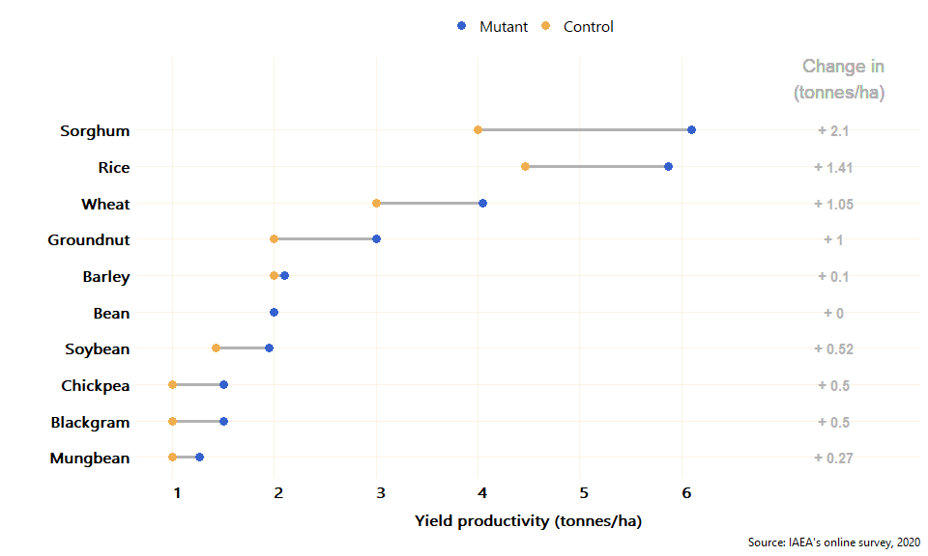

### Cumulative growing area

Approximately, **the total accumulated growing area, since 2000, of mutant crops in the 19 countries that participated in the online survey is 38,826 (in 1,000 ha)** [17]. From the 14 countries with at least one mutant variety developed, Pakistan is the country with the largest cumulative growing area of mutant crops: 16,200 (thousand ha). The second largest growing area is in China, followed by Thailand, Viet Nam, and Indonesia. From the countries with at least 1 mutant variety reported, Sri Lanka and Malaysia are the ones with the smallest cumulative growing area, 0.04 and 0.2 (1,000 ha) respectively. The average cumulative growing area of mutant crops in the RCA countries is 2,773 (thousand ha). Figure 7 shows the total cumulative growing area of mutant varieties since 2000 by country (e.g. if a country had a growing area of 10 ha for 10 years the graph would show 100 ha).

Figure 7: Total accumulated growing area of mutant crops since 2000 by country

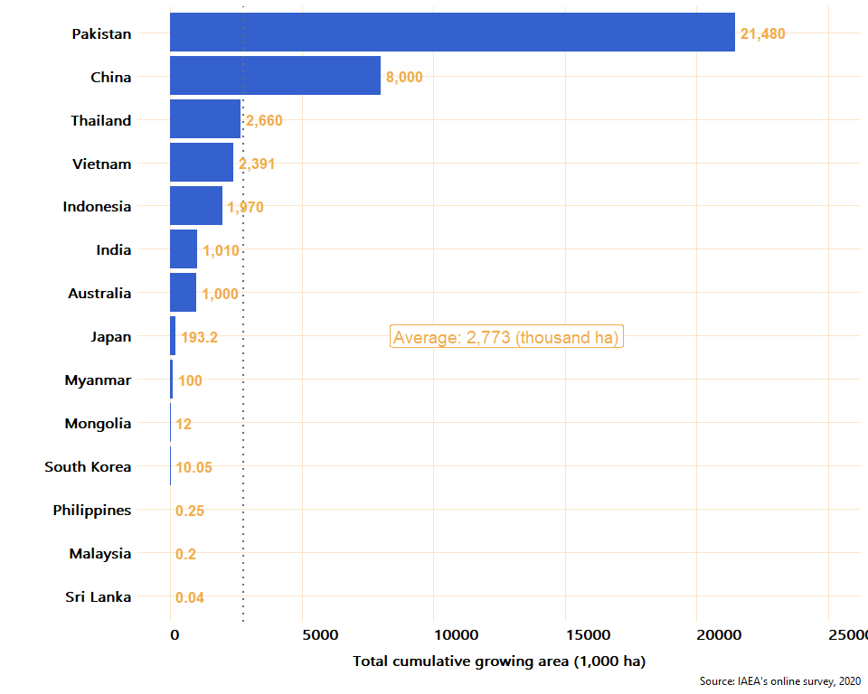

The crop with the largest accumulated growing area is chickpea with 13,200 thousand ha and it is grown only in Pakistan, followed by rice (9,575 thousand ha) that is grown in Japan, Pakistan, Myanmar, Indonesia, Viet Nam, Malaysia, Philippines, and South Korea. Table 3 summarises the total mutant lines, varieties and their total growing area (in thousand ha) and yield (tonnes/ha). To see the total growing area for each crop by country, see table 7 at the end of this annex.

Table 3: Cumulative growing area and productivity of mutant crops (sorted by growing area)

|  |  |  |  |  |
| --- | --- | --- | --- | --- |
| Crop | Lines developed | Varieties developed | Total cumulative growing area (1,000 ha) | Average yield (tonnes/ha) |
| Chickpea | 55 | 15 | 13,200 | 1.5 |
| Rice | 973 | 122 | 9,575 | 5.9 |
| Wheat | 5,165 | 45 | 8,012 | 4.0 |
| Mungbean | 178 | 19 | 4,380 | 1.3 |
| Soybean | 347 | 40 | 1,929 | 2.0 |
| Barley | 84 | 1 | 1,000 | 2.1 |
| Blackgram | 15 | 2 | 600 | 1.5 |
| Sorghum | 150 | 3 | 120 | 6.1 |
| Groundnut | 25 | 2 | 10 | 3.0 |
| Banana | 7 | 1 | 0.1 | 40.0 |
| Bean | 216 | 3 | 0.05 | 2.0 |
| Tomato | 2 | 1 | 0.035 | 35.0 |

*Source: IAEA’s online survey, 2020*

### Quality traits

As can be seen in Figure 8, from the 12 crops for which a mutant variety has been developed, 10 have improved at least one quality trait (such as gluten-free, grain size, grain shape, grain color, milling quality, eating quality, high mineral content, high oil content, and high seed protein content). In most cases, multiple traits have been improved.

Figure 8: Number of quality traits improved by mutant varieties



To check for consistency between countries on the quality traits improved, the proportion of responses that reported a positive improvement in quality crops was estimated. Thus, for each crop reported, the proportion of times the crop was reported to have improve a quality trait is presented in Figure 9.

Figure 9: Proportion of responses reporting improvement in quality traits of mutant varieties

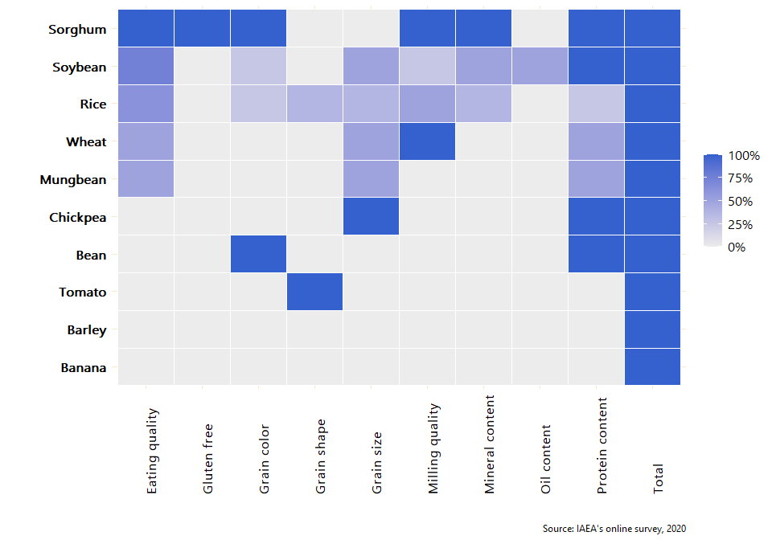

## Criterion 2: Enhanced environmental protection

Table 4: Key evidence for criterion 2

|  |  |  |
| --- | --- | --- |
| Evidence | Finding | Source |
| Weighted average reduction in chemical fertiliser use for each mutant variety | 21% | Online survey [18] |
| Weighted average reduction in pesticide use for each mutant variety | 17% | Online survey |
| Weighted average increase in water use efficiency | 12% | Online survey |
| Weighted average increase in soil fertility | 8% | Online survey |

### Enhanced environmental protection

To assess the environmental contribution of mutant varieties, the number of mutant crops that contribute to at least one environmental protection trait (reduction in pesticide use, reduction in chemical fertiliser use, increase in water efficiency, or increase in soil fertility) was estimated. It was found that **all the crops for which a variety has been developed contribute to at least one environmental protection trait without a significant reduction in production**. Figure 10 shows the proportion of responses, by crop, in which an enhancement in environmental protection was reported. From this figure, it can be seen that mutant varieties of soybean, rice, and sorghum have contributed to a reduction of pesticide use, and chemical fertiliser, and to an improvement of soil fertility and water efficiency; mutant varieties of tomato reduce the use of pesticides; and mungbean, chickpea, and bean improve soil fertility.

Figure 10: Proportion of responses reporting crops enhancing environmental protection

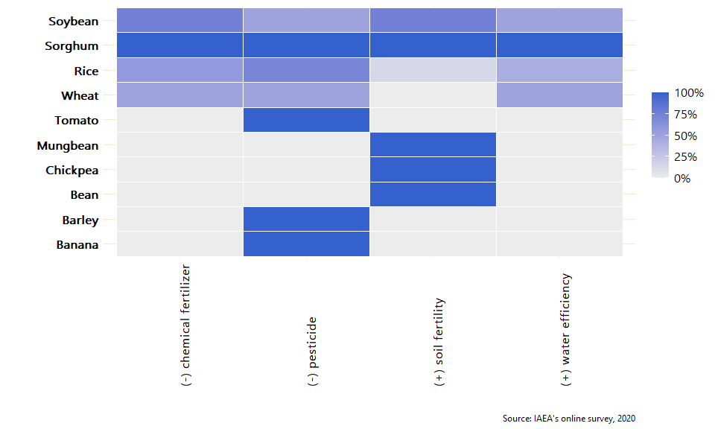

### Reduction in pesticide use

Compared to the use of pesticide for the control crops, seven mutant crops (banana, barley, rice, sorghum, soybean, tomato, and wheat) have reduced the use of pesticide. The weighted average reduction of pesticide is 21%. Figure 11 below shows the reduction in the use of pesticide, compared to its control, by all the mutant varieties reported in the online survey. The vertical dotted lines mark 8% and 15% which are considered in the criterion to be good and excellent respectively.

### Qualitative case from Philippines

"The mutant banana and rice varieties developed and disseminated to farmers or growers are resistant to pests and diseases such that no pesticide is necessary. In fact, there are banana growers who have 100% reduction in pesticide use but the average value should be reflected because we also considered those who use insecticide and fungicide for post-tissue culture protection of plantlets being established in the nursery before planting out in the field. For rice, the Philippine Department of Agriculture is promoting organic agriculture and farmers are encouraged to avoid using pesticides. Instead, Integrated Pest Management (IPM), specifically the use of predators or beneficial insects and other arthropods, is implemented and pesticide is used as the last resort. With mutant rice varieties that are tolerant or resistant to diseases and their vectors, there is 50% reduction in pesticide use. The cost of pesticides in the Philippines have become prohibitive to ordinary farmers, so that is why a majority of them could not afford to buy it and rely on IPM instead. The latest technology to reduce pesticide use and increase rice yield is the application of radiation-modified kappa-carrageenan solution on rice plants at specific stages."

Figure 11: Reduction in the use of pesticide compared to control groups

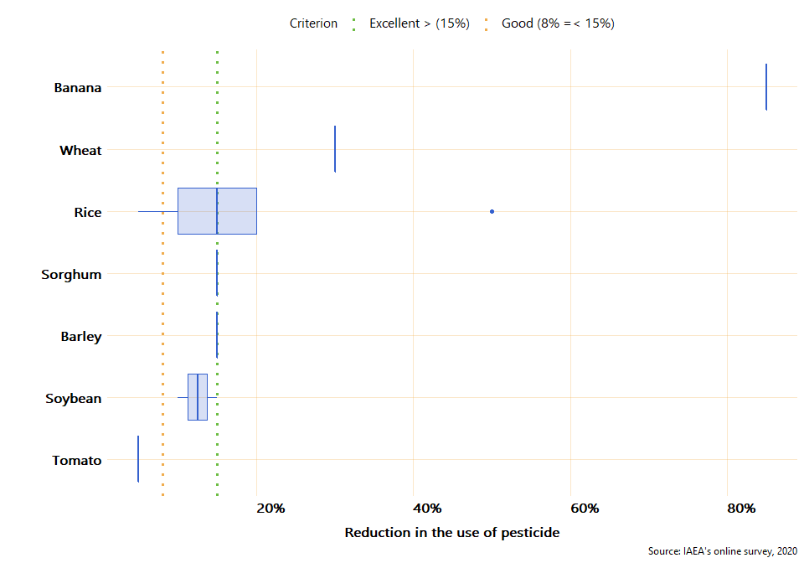

As it can be seen in the figure above, five crops have reduced, on average, the use of pesticide by 15% or more, one (soybean) has reduced it 10% and one (tomato) has reduced the use of pesticide 5% compared to its control crop.

### Reduction in chemical fertiliser use

Compared to control crops, four mutant varieties (rice, sorghum, soybean, and wheat) have reduced the use of chemical fertiliser. The weighted average reduction of chemical fertiliser, compared to control crops, is 17%. Wheat, Sorghum, and Soybean have reduced, on average, about 15% the use of chemical fertiliser. The green and yellow dotted lines in Figure 12 mark 20% and 10% which is considered in the criterion as excellent and good respectively.

Figure 12: Reduction in the use of chemical fertiliser compared to control crops

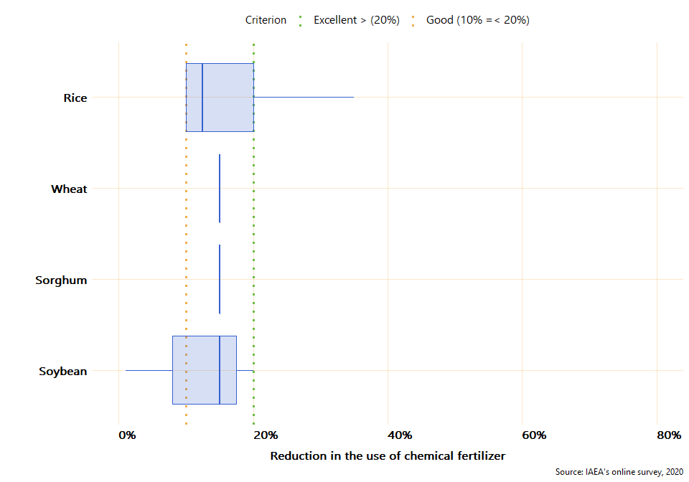

### Increase in water efficiency

Four mutant varieties (rice, sorghum, soybean, and wheat) have contributed to an increase of water efficiency compared to the control crops. The weighted average increase in water efficiency by mutant varieties is 12%. Figure 13 presents the increase of water efficiency of mutant varieties in comparison with its control crops. From the figure, it can be seen that Wheat increased by 25% the efficiency in the use of water compared to the control crop, and Sorghum 15%. The vertical green and yellow lines marked 20% and 10% increase in water efficiency which, according to the criterion, represent excellent and good respectively.

Figure 13: Increase in water efficiency compared to control crops

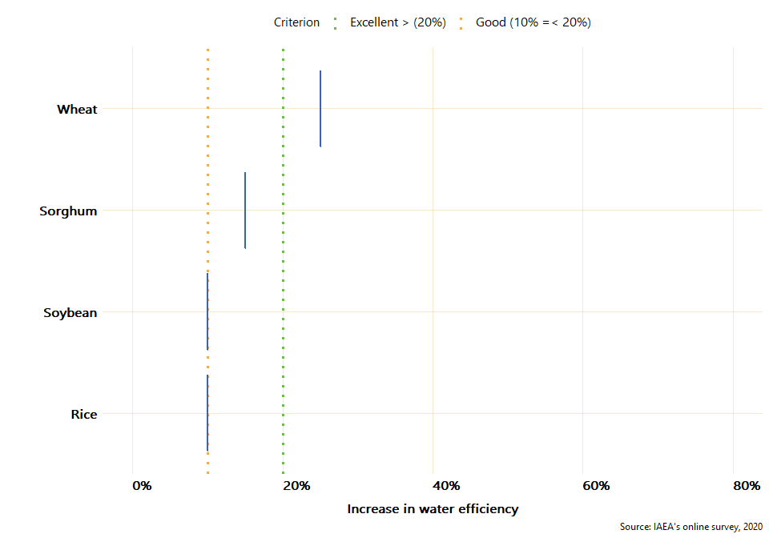

### Increase in soil fertility

Six mutant varieties (bean, chickpea, mungbean, rice, sorghum, and soybean) increased soil fertility compared to their control crops. On average (weighted), mutant varieties increased 8% soil fertility in comparison to control crops. Figure 14 presents the increase in soil fertility of each crop in comparison to its control.

### Qualitative case from Indonesia

"In Indonesia, after soybean cultivation farmers usually give lesser amount of nitrogen fertiliser than the control (10-15 % reduction) for the next growing crop. It is because soybean root system in symbiosis with agrobacterium can uptake nitrogen from the air and deposit them in the soil so that soil fertility increases significantly."

Figure 14: Increase in soil fertility compared to control crops

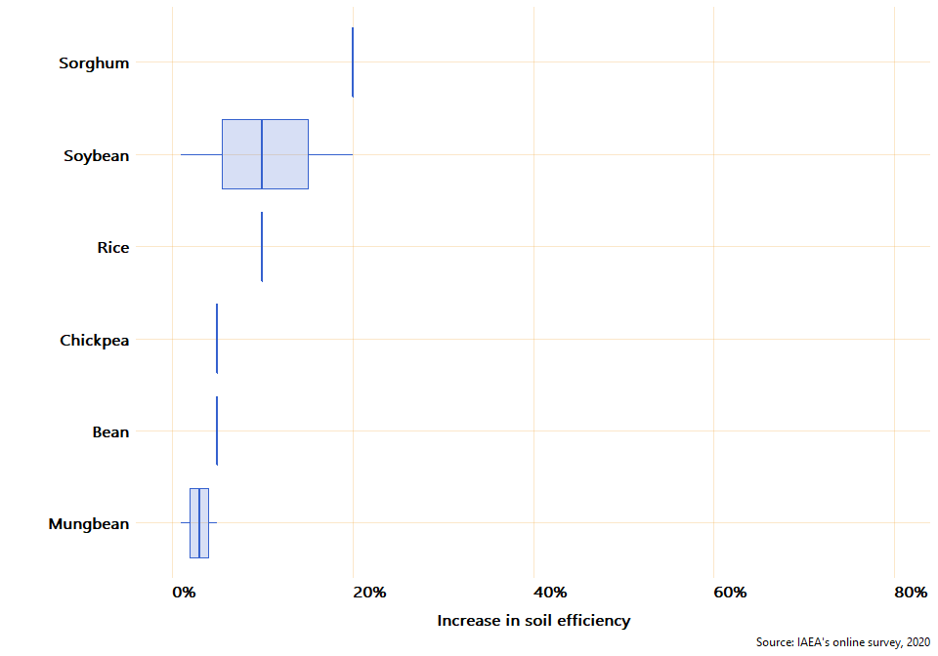

## Criterion 3: Strengthened regional capacity and sustainability

Table 5: Key evidence for criterion 3

|  |  |  |
| --- | --- | --- |
| Evidence | Finding | Source |
| Countries have a national team in mutation breeding | 73.7% | Online survey |
| Countries with access to field facilities | 89.5% | Online Survey |
| Countries with access to radiation facilities | 68.4% | Online survey |
| Number of group trainings in mutation breeding | 25 | Internal IAEA data |
| Numbers of people trained under RCA in mutation breeding and associated techniques | 470 | Internal IAEA data |
| Countries with trained personnel in mutation breeding | 19 | Internal IAEA data & online survey |
| Countries sharing knowledge with other countries | 13 | Online survey |
| Formal networks between countries and within countries | 353 | Online survey |
| Scientific Publications in mutation breeding produced by GPs | 977 | Online survey |

### National team and facilities for mutation breeding

The year in which a country started Mutation Breeding at the national level varies between countries. Countries like Japan, China, Sri Lanka, and India started in 1960 while countries like Laos, Cambodia or Palau started less than 15 years ago (See table below). As it can be seen in Table 6, **73.7% of the 19 countries that participated in the online survey have a national team in mutation breeding**, 89.5% have a field facility, and 68.4% have a radiation facility. It is worth noting that none of the countries that started a mutation breeding program earlier than 40 years ago has a radiation facility yet.

Table 6: Year in which mutation breeding started at the national level, human resources, and facilities by country

|  |  |  |  |  |  |
| --- | --- | --- | --- | --- | --- |
| Country | Year mutation breeding started at the national level | Total years | National team | Field facility | Radiation facility |
| Japan | 1960 | 60 | Yes | No | Yes |
| China | 1960 | 60 | Yes | Yes | Yes |
| Sri Lanka | 1960 | 60 | Yes | Yes | Yes |
| India | 1960 | 60 | Yes | Yes | Yes |
| South Korea | 1960 | 60 | Yes | Yes | Yes |
| Philippines | 1962 | 58 | Yes | Yes | Yes |
| Thailand | 1965 | 55 | Yes | Yes | Yes |
| Pakistan | 1970 | 50 | Yes | Yes | Yes |
| Myanmar | 1970 | 50 | Yes | Yes | Yes |
| Australia | 1971 | 49 | No | Yes | Yes |
| Bangladesh | 1972 | 48 | Yes | Yes | Yes |
| Indonesia | 1972 | 48 | Yes | Yes | Yes |
| Malaysia | 1975 | 45 | No | No | No |
| Viet Nam | 1978 | 42 | Yes | Yes | Yes |
| Mongolia | 1982 | 38 | Yes | Yes | No |
| Nepal | 1997 | 23 | No | Yes | No |
| Palau | 2009 | 11 | No | Yes | No |
| Laos | 2015 | 5 | Yes | Yes | No |
| Cambodia | 2018 | 2 | No | Yes | No |

*Source: IAEA’s online survey, 2020*

### Training in mutation breeding and associated techniques

According to IAEA’s internal data, since 2000, a total of 25 courses in mutation breeding have been conducted and **a total of 470 individuals have been trained in regional training courses under RCA projects**. Of the 470 individuals, 108 are women (23%). China is the country with the largest number of people trained with 47 trained individuals, followed by Viet Nam and Indonesia with 36 people trained each. On average, 21 people have been trained in each country under RCA projects since 2000 (Figure 15).

Figure 15: People trained in regional training courses under RCA by country

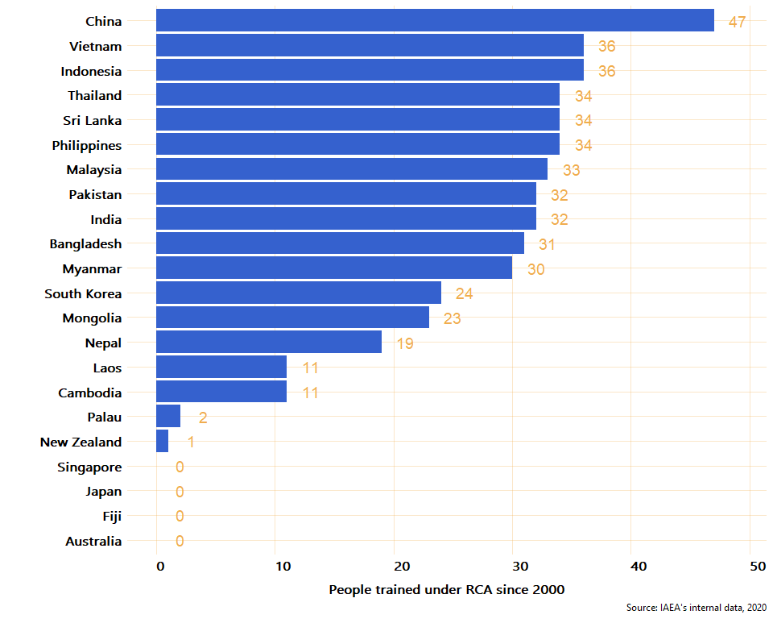

To estimate the level to which RCA has contributed to the development of human capacity in the different countries, the online survey and the internal tool were combined to analyse the number of countries for which personnel have been trained either in regional trainings or at the national level under RCA projects. In this respect, **19 out of the 22 countries have reported that personnel have been trained either at the national level or in regional training courses**[19]**.** From the 22 countries only Australia, Fiji, and Singapore did not report having received training under RCA. Japan is the only country that reported to have participated in training at the national level (online survey) but not having received training at the regional level (internal IAEA data)

### Qualitative cases from Mongolia, Thailand, Sri Lanka, and India

Mongolia  
"The RCA projects greatly contribute to the improvement of overall skill and capacity of our breeding team on the use of nuclear and screening of technique of mutation breeding. Use of nuclear and other screening facilities among member countries is very important for developing countries which don't have sufficient facility and resources"  
  
Thailand  
"Training support by RCA enhances the knowledge and ability of researcher, resulting in improving research and progress."  
  
Sri Lanka  
"The trainings offered by RCA for the capacity building of scientists assist them to acquire latest technologies to speed up mutation breeding. Scientists tend to use mutagenesis to create genetic variability in many crops using the newly installed gamma irradiation chamber facilitates through IAEA. The knowledge, skills and success stories shared in the progress review meetings and TOT trainings giving encouragement to the PIs and scientists to scale up the mutation breeding programs."  
  
India  
"Through RCA, approximately 20 scientists were trained on principles of mutation breeding & advanced tools. Because of RCA, several plant breeders are now using mutation breeding for crop improvement. Those trained through RCA are practicing mutation breeding in crops leading to development of improved breeding lines and now conducting training courses at national level. In the last 3 years, more than 100 young scientists were trained and we are receiving good appreciation from the breeding community."

### Expert missions and workshops

According to IAEA’s internal data, **26 expert missions have occurred since 2000 under RCA** to which 22 (5% women) national experts from 6 countries (China, Australia, Philippines, Pakistan, Myanmar, and India) have attended expert missions to other countries. Figure 16 presents the total number of national experts that have joined at least one expert mission to another country.

Figure 16: Number of experts that had joint missions to other countries under RCA

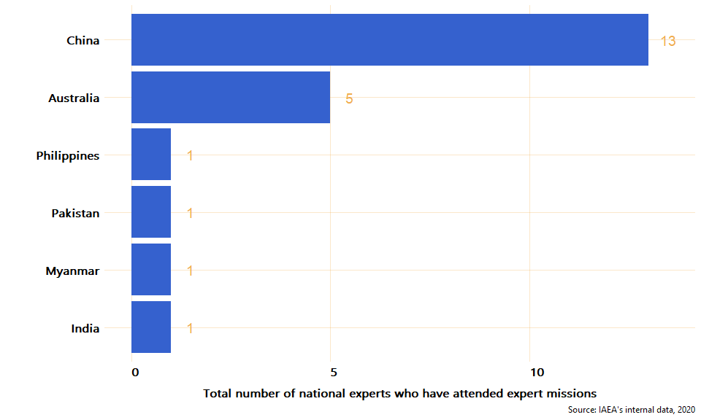

Moreover, **23 meetings/workshops for senior members in mutation breeding research** teams were facilitated. A total of 453 senior members have participated in these types of meetings and workshops.

### Qualitative cases from Laos and Pakistan

Laos   
"The main positive effect of RCA in Laos is human resource development because of TC and RCA project that our breeders have had chance to learn and develop mutation breeding. Second, develop mutation breeding network that our breeders have opportunity learn from other members and send our material for irradiating because we don't have equipment for irradiating. Third we got some equipment from TC and RCA for a breeding programme which helping speed up our breeding."  
  
Pakistan  
"Agricultural institutes of Pakistan expedite the process of variety development through expertise, collaborations, trainings and infrastructure development. Access to advanced technology from other member countries and trainings for new molecular techniques helped in rapid screening of mutant lines against biotic and abiotic stresses which minimizes the cost, time and labor. Learning from experiences of member states, mutation breeding program has also been extended to new crops like sesame."

### Publications in mutation breeding

In the online survey, country experts were asked to report the total number of publications in mutation breeding developed in each country since 2000. By publication, the study means: journal articles, newspaper articles, theses, books (and e-books), websites, conferences, online blogs, encyclopedia articles, etc. As a result, it was reported that **a total of 1,801 publications have been developed since 2000** in the 19 countries that participated in the online survey. From these publications, 54.2% are scientific publications. Figure 17 presents the total number of publications by type (scientific and non-scientific) and by country since 2000. *Note: This chart excludes China because the number reported of publications was very high (over 30,000).*

Figure 17: Number of publications since 2000 under RCA

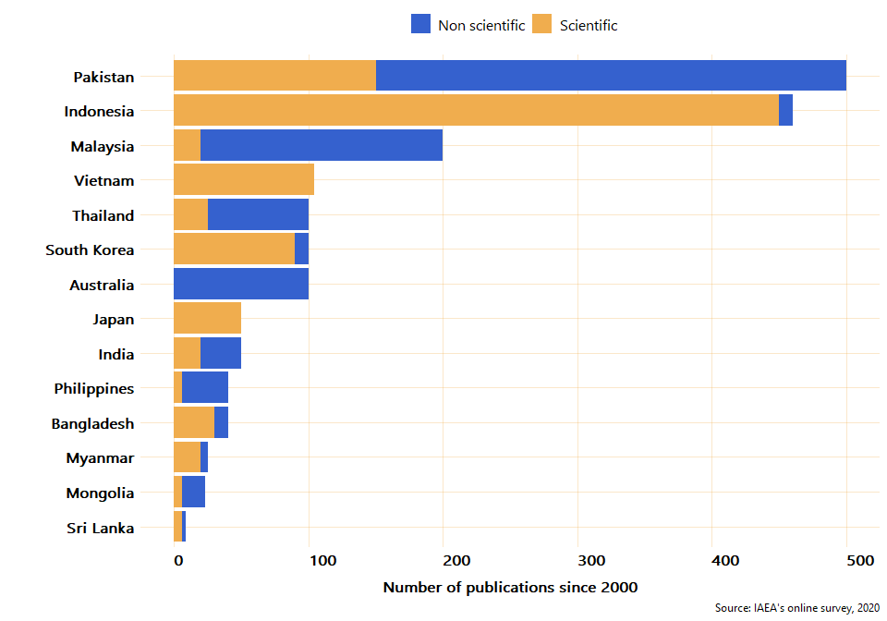

### Networking, collaboration, and knowledge transfer

To estimate the level of collaboration between countries, the online survey asked the experts if their country has provided services and knowledge related to mutation breeding to other countries. Examples of services and knowledge could be data, events, funding, infrastructure, jobs, projects, publications, research, skills shares, tools, etc. According to the answers provided by the experts, **a total of 13 RCA countries - Japan, Pakistan, Bangladesh, China, Indonesia, Thailand, Sri Lanka, India, Viet Nam, Malaysia, Australia, Philippines, and South Korea - have provided services and knowledge related to mutation breeding to other countries**. From these 13 countries that have shared knowledge or services with other countries, nine have shared skillshares and publications, eight have organized events, seven have shared research, and six have shared data. Figure 18 shows the number of countries that have shared the different types of collaboration with other countries.

Figure 18: Number of countries that have shared knowledge or services with other countries under RCA

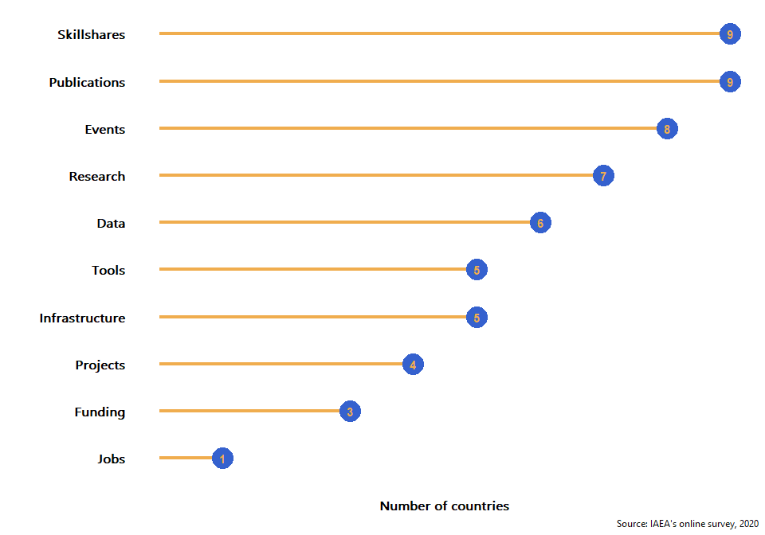

Moreover, to estimate the level and scope of networks within the countries and to approximate the level of connection with other national stakeholders, the online survey asked the experts to provide information about the number of companies/institutions that have cooperated with the country for mutation breeding, dissemination of mutant varieties, and contribution to knowledge. The online survey also asked for the approximate number of donors that have provided funding to research projects since 2000. Survey responses indicate that approximately **353 companies/institutions have cooperated with the partner countries in the dissemination of mutant varieties and about 85 donors have provided funds since 2000**. As can be observed in Figure 19, the level of cooperation and networking within countries varies between partners. From the 19 countries, only three - Cambodia, Myanmar, and Palau - did not report any relationship with other institutions or donors within their countries. For the other partners who have established cooperation with other national organisations, China and South Korea are the ones with a larger network of collaboration with other institutions, 100 and 80 respectively. As for the number of donors who have provided funding for research projects, since 2000, China, Pakistan, and India have reported 20, 15, and 10 contributions from donors respectively. From the countries that reported a collaboration with either a donor or an institution, only Thailand have not received funding from any donors.

Figure 19: Number of institutions and donors that have cooperated for mutation breeding by country

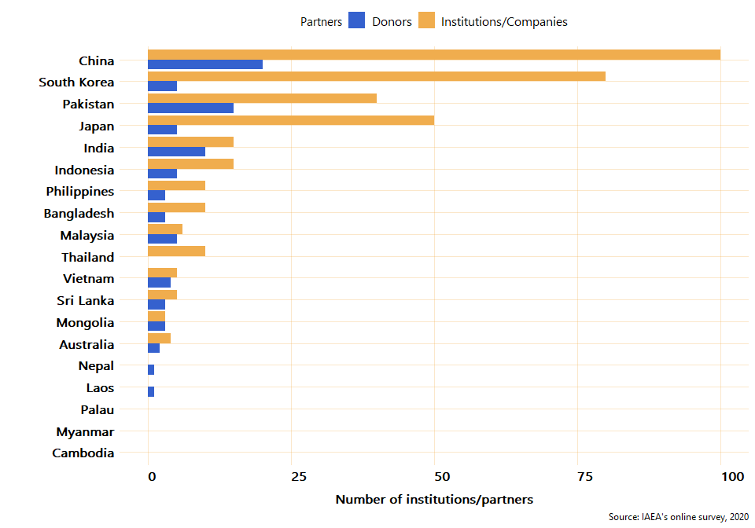

Table 7: Mutant lines and mutant varieties developed (by country and crop)

|  |  |  |  |  |  |  |
| --- | --- | --- | --- | --- | --- | --- |
| Country | Crop | Lines developed | Varieties developed | Cumulative Growing area (in thousand ha) | Yield (tonnes/ha) | Yield Control (tonnes/ha) |
| Australia | Barley | 80 | 1 | 1,000 | 2.1 | 2.00 |
| Australia | Lupin | 8 | 0 | NA | NA | NA |
| Australia | Oat | 12 | 0 | NA | NA | NA |
| Australia | Wheat | 50 | 0 | NA | NA | NA |
| Bangladesh | Groundnut | 0 | 0 | NA | NA | NA |
| Bangladesh | Rice | 0 | 0 | NA | NA | NA |
| Bangladesh | Sugarcane | 0 | 0 | NA | NA | NA |
| Cambodia | Banana | 0 | 0 | NA | NA | NA |
| Cambodia | Maize | 0 | 0 | NA | NA | NA |
| Cambodia | Rice | 1 | 0 | NA | NA | NA |
| China | Wheat | 5,000 | 42 | 8,000 | 6.5 | 5.00 |
| India | Blackgram | 15 | 2 | 600 | 1.5 | 1.00 |
| India | Groundnut | 20 | 2 | 10 | 3.0 | 2.00 |
| India | Mungbean | 30 | 3 | 400 | 1.5 | 1.00 |
| Indonesia | Rice | 200 | 25 | 1,050 | 7.5 | 5.00 |
| Indonesia | Sorghum | 100 | 3 | 120 | 6.1 | 4.00 |
| Indonesia | Soybean | 150 | 12 | 800 | 2.4 | 1.00 |
| Japan | Rice | 43 | 43 | 180.2 | 5.0 | 5.00 |
| Japan | Soybean | 17 | 17 | 13 | 1.7 | 1.70 |
| Laos | Mungbean | 10 | 0 | NA | NA | NA |
| Laos | Rice | 63 | 0 | NA | NA | NA |
| Laos | Soybean | 20 | 0 | NA | NA | NA |
| Malaysia | Banana | 3 | 0 | NA | NA | NA |
| Malaysia | Pineapple | 3 | 0 | NA | NA | NA |
| Malaysia | Rice | 10 | 1 | 0.2 | 10.0 | 5.00 |
| Mongolia | Barley | 4 | 0 | NA | NA | NA |
| Mongolia | Rice | 1 | 0 | NA | NA | NA |
| Mongolia | Wheat | 15 | 3 | 12 | 1.6 | 1.00 |
| Myanmar | Mungbean | 9 | 0 | NA | NA | NA |
| Myanmar | Rice | 26 | 5 | 100 | 4.5 | 3.00 |
| Myanmar | Sesame | 0 | 0 | NA | NA | NA |
| Nepal | Groundnut | 5 | 0 | NA | NA | NA |
| Nepal | Rice | 20 | 0 | NA | NA | NA |
| Nepal | Sugarcane | 25 | 0 | NA | NA | NA |
| Pakistan | Chickpea | 55 | 15 | 13,200 | 1.5 | 1.00 |
| Pakistan | Mungbean | 88 | 12 | 2,280 | 1.3 | 1.00 |
| Pakistan | Rice | 30 | 8 | 6,000 | 5.5 | 4.00 |
| Palau | Banana | 0 | 0 | NA | NA | NA |
| Palau | Groundnut | 0 | 0 | NA | NA | NA |
| Palau | Pineapple | 0 | 0 | NA | NA | NA |
| Philippines | Adlai | 1 | 0 | NA | NA | NA |
| Philippines | Banana | 4 | 1 | 0.1 | 40.0 | 30.00 |
| Philippines | Rice | 29 | 6 | 0.146 | 3.0 | 3.00 |
| Philippines | Sugarcane | 0 | 0 | NA | NA | NA |
| South Korea | Bean | 200 | 3 | 0.05 | 2.0 | 2.00 |
| South Korea | Oat | 50 | 0 | NA | NA | NA |
| South Korea | Rice | 400 | 4 | 10 | 5.0 | 4.75 |
| South Korea | Sorghum | 50 | 0 | NA | NA | NA |
| South Korea | Wheat | 100 | 0 | NA | NA | NA |
| Sri Lanka | Bean | 16 | 0 | NA | NA | NA |
| Sri Lanka | Mungbean | 1 | 0 | NA | NA | NA |
| Sri Lanka | Tomato | 2 | 1 | 0.035 | 35.0 | 30.00 |
| Thailand | Mungbean | 40 | 4 | 1,700 | 1.0 | 1.00 |
| Thailand | Soybean | 60 | 5 | 960 | 1.7 | 1.00 |
| Viet Nam | Rice | 150 | 30 | 2,235 | 6.5 | 6.00 |
| Viet Nam | Soybean | 100 | 6 | 156 | 2.0 | 2.00 |

*Source: IAEA’s online survey, 2020*

# Annex F: Economic Analysis

## Summary points

* Between 2000 and 2019 the RCA delivered excellent economic outcomes with estimated economic benefits significantly in excess of estimated costs.
* In our baseline scenario the RCA generated estimated net economic benefits of EUR15.8m. This includes costs and benefits incurred between 2000 and 2019, and projected benefits after 2019 from mutant varieties developed under the RCA between 2000 and 2019.
* Under alternative assumptions the estimated net benefits could be between EUR7.5m and EUR23.2m. In our view it is likely that the net benefits of the RCA were positive under almost all plausible assumptions about benefits and costs.
* Almost all benefits of the RCA came from speeding up the development of mutant varieties, compared to a hypothetical situation if there was no RCA. This means the main way the RCA generated economic benefits was by advancing the timing of commercial production of successful mutant varieties by helping to speed up the earlier stages of development of these varieties.
* The RCA also helped several countries to develop mutant varieties that they would not otherwise have developed in the absence of the RCA, but these crops are recently commercialised, and not yet grown in significant volumes so the associated economic benefits are small.
* Our estimates of benefits and costs are largely retrospective and are based on actual outcomes under the RCA between 2000 and 2019. These results should not be used to make decisions about the future of the RCA, or to decide whether the scale of the RCA should be increased or decreased.

## Overview

We developed a quantitative social cost-benefit model to estimate the economic impacts generated by the RCA between 2000 to 2019 (inclusive). This includes estimates of actual economic benefits and costs that occurred between 2000 and 2019, and projections of future benefits from 2020 onwards that are associated with ongoing production of mutant varieties of crops that were developed under the RCA before 2020.

Our economic analysis estimates the incremental economic benefits and costs that are attributable to *collaboration* in mutation breeding – i.e. we did not estimate the benefits and costs of mutation breeding activities as a whole but rather just the benefits and costs associated with collaboration under the RCA.

The economic analysis is based on production of mutant varieties of 25 crops developed in RCA member countries (of which survey data revealed 20 crops where the RCA contributed significantly to their development). For each of these crops, we estimated economic benefits of the crop relative to a non-mutant control variety due to various superior characteristics of the mutant variety such as greater yield and disease resistance. For each crop, we then attributed some or all of those benefits to the RCA, depending on the role that the RCA played in development of mutant varieties in the country where it was developed. From these benefits, we subtracted estimates of the costs incurred by the IAEA and by member countries that can be attributed to the RCA.

## Cost-benefit methodology

Our economic analysis is based on comparing annual estimates of economic outcomes of mutation breeding projects under the RCA versus a hypothetical counterfactual scenario where there is no RCA. The economic model estimated the aggregate differences in economic benefits and costs between these two scenarios. Benefits and costs were estimated on an annual basis and were converted to present values (2020 Euros) using an appropriate discount rate (see below for details).

## High-level effects of participating in the RCA on development of mutant varieties

Based on information provided by experts in mutation breeding from countries participating in the RCA, we understand that the RCA had different effects on mutation breeding activities in different countries. Experts reported the following effects of the RCA on the development of mutant varieties in their countries between 2000 and 2019:

* *New varieties*: The RCA enabled mutant varieties to be developed that would not otherwise have been developed without the RCA (reported by 5 countries).
* *Speed-up*: Development of mutant varieties was speeded up by the RCA, i.e. mutant varieties developed by the country would still have been developed without the RCA, but development would have taken more time (reported by 10 countries).
* *No effect*: The RCA had no significant effects on the development of mutant varieties (reported by 7 countries).

Based on the available information from country experts, each RCA member country was placed into one of the three categories above. For countries where the RCA led to faster or additional development of mutant varieties compared to if there was no RCA (i.e. mutant varieties developed in countries in categories 1 or 2 above), we assumed that this led to economic benefits and costs that can be attributed to the RCA.

Our analysis focuses on economic benefits that are realised when mutant varieties enter into commercial production. Development of mutant varieties that have not yet entered into commercial production may also generate some economic benefits, for example by contributing to potential future food security or health benefits but such benefits are difficult to quantify and are excluded from our analysis. We also modelled economic costs associated with the RCA itself and associated with additional mutation breeding activities in member countries that were due to the RCA (see below).

## Mutant varieties included in the cost-benefit analysis

Experts from countries participating in the mutation breeding projects under the RCA were surveyed and asked to provide information on mutant varieties that were developed in their country under the RCA. From this we obtained information about 25 crops where mutant varieties are in commercial production in the respective countries and where development was connected to the RCA. The relevant crops are shown in Table 8, including the year in which mutation breeding development started, the year that mutant varieties entered commercial production, and the reported accumulated (total) growing area of mutant varieties of each crop between 2000 and 2019. Table 8 also shows the reported impact category of the RCA for each country, which we assume applies to all mutant varieties developed in that country between 2000 and 2019.

Table 8: Crops with mutant varieties included in the economic analysis

|  |  |  |  |  |  |
| --- | --- | --- | --- | --- | --- |
| **Country** | **Crop** | **RCA impact category for country** | **Year development started** | **Year entered commercial production** | **Accumulated growing area from 2000 to 2019 (ha)** |
| Australia | Barley | (3) No effect | 2005 | 2010 | 1,000,000 |
| China | Wheat | (2) Speed-up | 1957 | 2000 | 8,000,000 |
| India | Blackgram | (2) Speed-up | 1970 | 1985 | 600,000 |
| India | Groundnut | (2) Speed-up | 1960 | 1973 | 10,000 |
| India | Mungbean | (2) Speed-up | 1970 | 1983 | 400,000 |
| Indonesia | Rice | (2) Speed-up | 1972 | 1978 | 1,050,000 |
| Indonesia | Sorghum | (2) Speed-up | 2005 | 2013 | 120,000 |
| Indonesia | Soybean | (2) Speed-up | 1975 | 1981 | 800,000 |
| Japan | Rice | (2) Speed-up | 1959 | 1966 | 180,223 |
| Japan | Soybean | (2) Speed-up | 1960 | 1966 | 13,000 |
| Korea | Bean | (3) No effect | 1995 | 2010 | 50 |
| Korea | Rice | (3) No effect | 1995 | 2005 | 10,000 |
| Malaysia | Rice | (2) Speed-up | 2005 | 2019 | 200 |
| Mongolia | Wheat | (1) New varieties | 1972 | 1986 | 12,000 |
| Myanmar | Rice | (2) Speed-up | 1970 | 1974 | 100,000 |
| Pakistan | Chickpea | (2) Speed-up | 1972 | 1982 | 13,200,000 |
| Pakistan | Mungbean | (2) Speed-up | 1974 | 1983 | 2,280,000 |
| Pakistan | Rice | (2) Speed-up | 1966 | 1977 | 6,000,000 |
| Philippines | Banana | (3) No effect | 2000 | 2017 | 100 |
| Philippines | Rice | (3) No effect | 1962 | 1970 | 146 |
| Sri Lanka | Tomato | (1) New varieties | 2003 | 2010 | 35 |
| Thailand | Mungbean | (2) Speed-up | 1996 | 2009 | 1,700,000 |
| Thailand | Soybean | (2) Speed-up | 1987 | 2006 | 960,000 |
| Viet Nam | Rice | (2) Speed-up | 1978 | 1990 | 2,234,530 |
| Viet Nam | Soybean | (2) Speed-up | 1983 | 1993 | 156,000 |

*Source: Survey of mutation breeding experts in RCA member countries.*

As seen in Table 8, some of the mutant varieties that survey respondents included as being developed under the RCA had already entered commercial production before 2000, i.e. before the start of our economic evaluation. However, mutation breeding experts from the IAEA advised us that there was likely to have been ongoing further development under the RCA of these crops that were introduced before 2000, and hence some benefits associated with crops that were introduced before 2000 may still be attributed to the RCA between 2000 and 2019. In consultation with IAEA experts, we assumed that benefits from crops introduced before 2000 could be attributed to the RCA after 2000 in cases where the country reported that the RCA enabled them to develop additional mutant varieties that would not have been developed without the RCA (i.e. countries in category 1 above).

## Modelling economic benefits of the RCA

Our estimates of the economic benefits of the RCA for the historic period from 2000 to 2019 are based on the 25 crops listed in Table 8 above. For each of those crops, we estimated benefits of the mutant variety relative to a non-mutant control variety that are due to:

* Differences in crop yield. Mutant varieties typically have greater yield (tonnes produced per hectare of crop) compared to control varieties.
* Differences in market price. Mutant varieties typically sell for higher market prices compared to control varieties, due to superior characteristics.
* Changes in production costs, accounting for both changes in production volumes and changes in average costs per tonne produced (see below).

For each crop, we then attributed some or all of these differences to the RCA depending on the impact of the RCA reported by the relevant country expert on the development of mutant varieties in that country and depending on whether the variety entered commercial production before the year 2000 or afterwards.

In countries where the RCA led to additional development of mutant varieties (i.e. countries in category 1 above), the economic benefits of the RCA come from the introduction of mutant varieties that would not have existed without the RCA. In such cases we attributed to the RCA all of the benefits of such varieties relative to the control variety for crops that were introduced to commercial production in the year 2000 or later. For crops that were introduced to commercial production before the year 2000, in the baseline case we assumed that 25% of the benefits of the mutant variety relative to the control variety are attributed to the RCA between 2000 and 2019, based on an assumption that there was ongoing further development of such mutant varieties under the RCA, as described above.

In countries where the RCA led to faster development of mutant varieties (i.e. countries in category 2 above), the economic benefits of the RCA come from the change in timing of the benefits of mutant varieties relative to control varieties. In general, economic benefits (or costs) are greater when they occur earlier in time, everything else being equal. This is because societies and individuals generally prefer consumption that occurs sooner rather than later, due to uncertainties about future outcomes. For example, people would generally prefer to receive a payment of $100 now rather than a promise of $100 in a year’s time, because there is some uncertainty about whether the future payment will occur and/or whether the individual will still be alive to consume it. Therefore, in cases where the RCA speeded up development of mutant varieties, the fact that the benefits of these varieties occurred earlier in time generates an economic benefit, even if the total amount of benefits generated over time is unchanged. In addition, earlier access to new crops may generate social benefits by improving the ability of poorer populations to access new food sources, reducing malnutrition and child mortality.

In cases where the RCA speeded up development of mutant varieties, we assumed that the benefits of such mutant varieties relative to control varieties would have been the same without the RCA but would have occurred later in time. This change in timing generates an economic benefit due to the opportunity cost of time factored into the present value calculations, as explained above. We attributed the effects of this change in timing to the RCA for crops that entered commercial production in the year 2000 or later. For crops that entered production prior to 2000, the benefits from the change in timing occurred prior to our evaluation period and thus are not included in our estimated benefits of the RCA between 2000 and 2019.

These assumptions about the benefits of mutant varieties that are attributed to the RCA are summarised in Table 9. In practice, these assumptions mean that our estimates of the economic benefits of the RCA are based on the following impacts on specific crops in specific countries:

* Enabled development of mutant varieties of tomato in Sri Lanka
* Speeded up development of mutant varieties of sorghum in Indonesia, rice in Malaysia, wheat in Mongolia, mungbean in Thailand, and soybean in Thailand.

Table 9: Summary of assumed benefits of mutant varieties attributed to the RCA

|  |  |  |
| --- | --- | --- |
| **Year entered commercial production** | **RCA impact category for country** | **Assumed benefits of mutant varieties attributed to the RCA** |
| Before 2000 | (1) New varieties | Partial  (Baseline 25%, low 0%, high 50%) |
| Before 2000 | (2) Speed-up | None |
| Before 2000 | (3) No effect | None |
| 2000 to 2019 | (1) New varieties | Full benefits of mutant varieties vs control varieties |
| 2000 to 2019 | (2) Speed-up | Time-shift effect |
| 2000 to 2019 | (3) No effect | None |

For each of the 25 crops shown in Table 8, we estimated economic benefits relative to a non-mutant control variety arising from some or all of:

* Increased crop yield, i.e. increased production per hectare, assuming that the same growing area as reported for mutant varieties between 2000 and 2019 would have been allocated to control varieties of the same crop if the mutant varieties had not been developed.[20]
* Increased market price, which translates to increased revenue for farmers, everything else equal.
* Changes in costs of production associated with use of chemical fertiliser and pesticides.

Table 10 on the following page summarises the relevant characteristics of the 25 mutant varieties included in our analysis. Overall, we see increased yield and increased market price in 19 out of 25 crops, reduced costs of chemical fertilisers per tonne of produce in 9 crops, and reduced costs of pesticides per tonne of produce in 11 crops. It is important to note that while the costs of fertilisers and pesticides are typically lower *per tonne* for mutant varieties compared to control varieties, in many cases we estimate that the *total* costs of fertilisers and pesticides for the mutant varieties are *greater* than the control varieties, due to increased yields and increased production of mutant varieties.

Table 10: Economic characteristics of crops used to estimate economic benefits of the RCA

|  |  |  |  |  |  |  |  |  |  |  |
| --- | --- | --- | --- | --- | --- | --- | --- | --- | --- | --- |
| **Country** | **Crop** | **Yield of mutant variety (tonnes/ha)** | **Yield of control variety (tonnes/ha)** | **Market price of mutant variety (USD/tonne)** | **Mutant variety vs control variety price differential** | **Fertiliser cost of mutant variety (USD/tonne)** | **Fertiliser cost of mutant variety vs control** | **Pesticide cost of mutant variety (USD/tonne)** | **Pesticide cost of mutant variety vs control** | **Estimated other variable costs (USD/tonne)** |
| Australia | Barley | 2.1 | 2.0 | 255 | No change | 30.24 | No change | 22.66 | -15% | 147.10 |
| China | Wheat | 6.5 | 5.0 | 336 | +1.0% | 60.80 | -15% | 17.37 | -30% | 169.80 |
| India | Blackgram | 1.5 | 1.0 | *128 | No change | 40.00 | No change | 33.00 | No change | 29.24 |
| India | Groundnut | 3.0 | 2.0 | *480 | No change | 70.00 | No change | 80.00 | No change | 234.00 |
| India | Mungbean | 1.5 | 1.0 | *971 | No change | 35.00 | No change | 40.00 | No change | 701.80 |
| Indonesia | Rice | 7.5 | 5.0 | 730 | +10.0% | 14.14 | -10% | 10.60 | -15% | 502.73 |
| Indonesia | Sorghum | 6.1 | 4.0 | 365 | +15.0% | 5.30 | -15% | 3.53 | -15% | 243.52 |
| Indonesia | Soybean | 2.4 | 1.0 | 437 | +10.0% | 10.60 | -15% | 7.07 | -10% | 297.49 |
| Japan | Rice | 5.0 | 5.0 | 1360 | No change | 146.78 | -10% | 128.43 | -10% | 782.22 |
| Japan | Soybean | 1.7 | 1.7 | 1280 | +1.0% | 256.86 | -1% | 192.64 | No change | 561.77 |
| Korea | Bean | 2.0 | 2.0 | 8440 | No change | 80.00 | No change | 70.00 | No change | 6602.00 |
| Korea | Rice | 5.0 | 4.8 | 253 | +10.0% | 83.00 | No change | 50.00 | No change | 51.00 |
| Malaysia | Rice | 10.0 | 5.0 | 292 | +15.0% | 26.55 | -15% | 28.97 | -5% | 141.40 |
| Mongolia | Wheat | 1.6 | 1.0 | 200 | +7.0% | 101.67 | No change | 14.53 | No change | 33.33 |
| Myanmar | Rice | 4.5 | 3.0 | 1035 | No change | 164.66 | -35% | 46.11 | No change | 528.57 |
| Pakistan | Chickpea | 1.5 | 1.0 | 561 | +10.0% | 53.32 | No change | 20.00 | No change | 334.68 |
| Pakistan | Mungbean | 1.3 | 1.0 | 971 | +10.0% | 66.65 | No change | 33.33 | No change | 606.21 |
| Pakistan | Rice | 5.5 | 4.0 | 259 | +5.0% | 33.33 | No change | 16.66 | No change | 147.35 |
| Philippines | Banana | 40.0 | 30.0 | 597 | No change | *120.00 | No change | *63.11 | No change | 294.49 |
| Philippines | Rice | 3.0 | 3.0 | 320 | No change | *79.32 | No change | *42.59 | -50% | 91.51 |
| Sri Lanka | Tomato | 35.0 | 30.0 | 633 | +15.0% | 6.66 | No change | 20.03 | -5% | 412.61 |
| Thailand | Mungbean | 1.0 | 1.0 | 2665 | +5.0% | 200.00 | No change | 333.00 | No change | 1497.48 |
| Thailand | Soybean | 1.7 | 1.0 | 2517 | +5.0% | 200.00 | No change | 200.00 | No change | 1517.71 |
| Viet Nam | Rice | 6.5 | 6.0 | 430 | +40.0% | 86.77 | No change | 17.35 | -20% | 137.26 |
| Viet Nam | Soybean | 2.0 | 2.0 | 774 | +10.0% | 95.44 | -20% | 86.77 | -15% | 341.53 |

*\* Information not supplied by country experts was estimated from other sources*

Our survey of country experts in mutation breeding indicated that mutant varieties have various other superior characteristics relative to non-mutant varieties such as improved tolerance of drought, salt, and submergence, better water efficiency, and improved quality traits such as shape, colour, and eating quality. Due to a lack of information about the commercial significance of such differences, we have not included effects other than those listed above in our estimates of the economic benefits of mutant varieties. Due to these omissions, it is possible that the actual economic benefits of mutant varieties relative to the control varieties are greater than we have estimated.

We did, however, estimate changes in other variable costs of producing crops aside from fertilisers and pesticides, e.g. labour costs and transportation. We assumed that the gross profit margin per tonne of mutant varieties is 20% (with low and high scenarios of 10% and 30%). This assumption, together with the reported costs of fertilisers and pesticides per tonne, allowed us to estimate total other operating costs per tonne. We assumed that this cost per tonne is the same for both mutant and control varieties of the same crop. The estimated values of these other costs are shown in the final column of Table 10.

We estimated the benefits of mutant varieties that are attributable to the RCA for six years (with low and high scenarios of three years and nine years) from when the crop entered commercial production, or from the year 2000 for crops that entered commercial production before 2000 and were further developed after that date under the RCA. Mutation breeding experts from RCA member countries told us that the typical commercial lifetime of mutant varieties ranges from two years to indefinite, and is often around 5-7 years. This suggests that the benefits from some mutant varieties are relatively short-lived. In addition, we expect that over time market forces will erode the economic benefits of mutant varieties as more farmers adopt crops with superior characteristics leading to a change in market prices, and as alternative (non-mutant) crops also improve due to other development. For these reasons, in our view it is reasonable to limit the period over which the benefits of the mutant varieties are attributed to the RCA.

For each crop we estimated annual production of the mutant variety from the figures for the accumulated growing area between 2000 and 2019 from Table 8 and the yield of the mutant variety from Table 9. We also calculated what production of the control variety would have been if the same growing area was used, based on the control variety yield in Table 9. As we did not have annual production data, we assumed that the same growing area was used for each crop in each year. Thus, we calculated the annual growing area for each crop by dividing the accumulated growing area figures in Table 8 by the appropriate number of years of production between 2000 and 2019.[21] The assumed annual growing area of each mutant variety is illustrated in Figure 20.

Figure 20: Assumed annual growing area of mutant varieties between 2000 and 2019



To illustrate the relative importance of mutant varieties included in this analysis, Figure 21 shows our estimates of the total benefits between 2000 and 2019 by crop (modelled for a maximum of six years for each crop, as explained above). These figures reflect the combined effect of the estimated growing area of mutant varieties between 2000 and 2019, the relative yields of mutant and control varieties, and differences in chemical fertiliser and pesticide costs. On the chart, the six mutant varieties that we estimate were directly impacted by the RCA are highlighted. The remaining mutant varieties were assumed to not have been impacted by the RCA between 2000 and 2019 based on the assumptions summarised in Table 9 above.

Figure 21: Estimated (undiscounted) benefits of mutant varieties relative to control varieties between 2000 and 2019



## Modelling economic costs of the RCA

In addition to the benefits described above, it is reasonable to assume that the RCA also generated some economic costs relative to a hypothetical scenario in which there was no RCA. These costs reflect the opportunity costs arising from committing resources of the IAEA and of RCA member countries to RCA-related activities. The following costs were estimated for the period from 2000 to 2019:

* Costs incurred by the IAEA associated with conducting RCA mutation breeding activities including training courses, workshops, expert missions, and other activities.
* Costs incurred by RCA mutation breeding member countries for participating in those activities.
* Costs associated with development of additional mutant varieties of crops in countries where participating in the RCA enabled them to develop additional mutant varieties.
* Overhead costs associated with all of the above.

#### Economic costs incurred by the IAEA associated with RCA mutation breeding activities

The IAEA provided us with information about its costs in relation to RCA mutation breeding activities between 2000 and 2019. These included costs associated with organising mutation breeding meetings, training courses, expert missions, and other activities, in Vienna and in member countries. Total reported costs over the period from 2000 to 2019 were EUR2.42m.

Based on the information provided by the IAEA, we categorised costs by type of activity and calculated the average and total cost for each type of activity between 2000 and 2019 (Table 11). The average cost per type of activity shown in Table 11 was used to estimate annual costs, while ensuring that the estimated total costs over the period from 2000 to 2019 add up to the same total (EUR 2.42m).

Table 11: Costs incurred by the IAEA associated with RCA mutation breeding activities

|  |  |  |
| --- | --- | --- |
| **Activity** | **Average (EUR)** | **Total (EUR)** |
| Meeting | 54,270 | 814,055 |
| Training course | 79,487 | 1,192,305 |
| Expert mission | 7,394 | 81,332 |
| Other | 19,303 | 154,424 |
| Total |  | 2,242,116 |

*Source: Calculated from cost and activity data provided by the IAEA.*

Figure 22 shows the number of each type of activity facilitated by the IAEA in each year between 2000 and 2019. We used these activity counts to estimate annual costs incurred by the IAEA to organise the RCA. In addition to these direct operating costs, we also added a 10% premium (with scenarios of 5% and 20%) to account for overhead costs of the IAEA (e.g. administration and central office costs).

Figure 22: Annual number of mutation breeding activities facilitated by the IAEA



*Source: IAEA*

#### Economic costs incurred by member countries associated with RCA mutation breeding activities

We assumed that RCA member countries incurred costs to participate in RCA mutation breeding activities associated with opportunity costs of time for those attending mutation breeding training courses and meetings, etc (direct travel and accommodation costs were funded by the IAEA and are included in the estimates of the IAEA’s costs above). For each member country, we estimated these costs for each year between 2000 and 2019 based on information provided by the IAEA about the number of people from that country who attended RCA mutation breeding workshops and meetings.

The total number of people from RCA mutation breeding member countries who attended these activities in each year is shown in Figure 23.[22] We understand that a mutation breeding training course runs for approximately two weeks on average, and a mutation breeding meeting or workshop runs for approximately one week on average.

Figure 23: Annual number of people from RCA mutation breeding member countries who attended RCA mutation breeding activities organised by IAEA



*Source: IAEA.*

We assumed that there were opportunity costs associated with people from RCA member countries who attended mutation breeding courses and meetings being unable to do other productive work during that time. We estimated these costs for each member country based on the number of people from that country who attended RCA mutation breeding activities in each year and assumed that opportunity costs per person-day are proportional to that country’s real GDP per capita in that year. In general, people who attend mutation breeding courses and workshops are highly skilled workers and thus earn more than the average worker. To accommodate this, we calculated opportunity costs based on a multiple of real GDP per capita for each country, where the multiple was determined from information from the International Labor Organization about the relative costs of skilled labour in each country.

These assumptions are summarised in Table 12 (for brevity, only GDP figures for 2019 are shown, but the cost estimates were based on similar GDP figures for other years). On average across member countries, we assumed that opportunity costs of time for attending mutation breeding training courses and workshops are around 1.5 times higher than overall real GDP per capita in each member country. We used these estimates together with information from the IAEA about the number of people from each member country who attended mutation breeding training courses and workshops to estimate the opportunity costs incurred by each member country, assuming that each mutation breeding training course lasts for two weeks and each workshop lasts for one week. As with the IAEA’s costs, we also assumed that member countries incurred additional overhead costs at a rate of 10% in the baseline scenario.

Table 12: Opportunity cost of time assumptions for RCA member countries

|  |  |  |
| --- | --- | --- |
| **Country** | **2019 real GDP per capita (USD)** | **GDP per capita multiple for high skill labour cost** |
| Australia | 49,756 | 1.33 |
| Bangladesh | 4,754 | 1.70 |
| China | 16,117 | *1.47 |
| Cambodia | 4,389 | 1.34 |
| Fiji | 13,853 | 1.80 |
| India | 6,754 | *1.47 |
| Indonesia | 11,812 | 1.47 |
| Japan | 41,429 | *1.47 |
| Korea, Rep. | 42,661 | 1.15 |
| Lao PDR | 7,826 | 0.88 |
| Malaysia | 28,351 | 1.94 |
| Mongolia | 12,310 | 1.14 |
| Myanmar | 5,142 | 1.09 |
| Nepal | 3,417 | 1.18 |
| New Zealand | 42,888 | *1.47 |
| Pakistan | 4,690 | 1.81 |
| Palau | 18,364 | *1.47 |
| Philippines | 8,908 | 2.10 |
| Singapore | 97,341 | 1.68 |
| Sri Lanka | 13,078 | 1.58 |
| Thailand | 18,463 | 2.00 |
| Viet Nam | 8,041 | 1.47 |

*Source: World Bank and International Labor Organization.*

*\* Value not available, so the average value for all other countries was used.*

#### Economic costs incurred by member countries associated with additional development of mutant varieties

For countries where mutation breeding experts indicated that participating in the RCA enabled the development of additional mutant varieties, we attribute the costs of development of those varieties to this RCA. This is because, while these are not direct costs of the RCA itself, they would not have been incurred without the RCA and thus should be counted as economic costs associated with the RCA.

We assumed that additional mutant variety development costs were incurred in all RCA member countries where mutation breeding experts from those countries told us that the RCA led to the development of additional mutant varieties: Bangladesh, Laos, Mongolia, Nepal, and Sri Lanka. We attributed these costs to the RCA regardless of whether this development led to commercially successful mutant varieties, since the costs of unsuccessful (or not yet successful) development are still costs that were created by the RCA.

We estimated the costs incurred by these countries to develop additional mutant varieties under the RCA based on information provided by mutation breeding experts about the amount of effort required to develop a new mutant variety. On average, we assumed that developing a new variety requires 5,400 person-days of effort (with low and high scenarios of 4,000 and 6,800 days). For Sri Lanka, we assumed that this development was associated with the commercially successful tomato variety (see Table 9 above), with costs incurred over the period from 2003 to 2009. For the other four countries, we assumed that these costs were incurred between 2000 and 2009, based on information from mutation breeding experts that development of mutant varieties takes around ten years on average.

To translate these estimates of development effort into costs, we used the same estimates of labour costs as used to calculate the opportunity costs for each country of attending RCA mutation breeding training courses and workshops (see Table 12 above). We also assumed each country incurred an additional 10% of overhead costs associated with administrative costs of their mutation breeding programme.

## Net present value and break-even calculations

A key measure of the economic impacts of the RCA is the net present value (NPV) of the estimated benefits minus the estimated costs, i.e. the estimated net economic impacts that are attributable to the RCA. We express the NPV in 2020 values after adjusting for the timing of these benefits and costs. As explained above, the NPV includes benefits and costs incurred between 2000 and 2019, and some benefits expected to be incurred beyond 2019 that are attributable to mutant varieties developed under the RCA between 2000 and 2019.

This cost-benefit analysis is mainly retrospective, i.e. it primarily evaluates outcomes that have already occurred. The usual practice in a forward-looking social cost-benefit analysis (i.e. an analysis that is based on projections of future outcomes) is to discount future outcomes by a multiple that depends on a social discount rate and how far into the future these outcomes occur. Specifically, the discounted value of a benefit or a cost *x* that occurs *t* years in the future given a social discount rate of *r* is *x* / (1 + *r*)*t*. In forward-looking social cost-benefit analysis, the justification for such discounting is that there is uncertainty about whether future outcomes will occur, and this uncertainty means that benefits and costs that occur now have greater value than those that occur in the future.

In a retrospective cost-benefit analysis there is no uncertainty about whether outcomes will occur, since these have already occurred. However, to be consistent with the justification for discounting in a social cost-benefit analysis, it is necessary to carry out a retrospective analysis *as if* it were a forward-looking analysis and to discount benefits and costs over time in the same way. For this reason, our analysis discounts all benefits and costs incurred between 2000 and 2019 back to the year 2000, i.e. the cost-benefit analysis is structured as if we were carrying out the cost-benefit analysis at the beginning of our evaluation period. For ease of interpretation, we express all benefits and costs in real 2020 euros, i.e. excluding changes in the value of money over time due to inflation.

Our analysis used a discount rate of 10.2% (low scenario 5.2%, high scenario 15.2%) for benefits and costs that occur between 2000 and 2019 and a discount rate of 8.2% (low scenario 3.2%, high scenario 13.2%) for benefits that occur in 2020 and beyond. These rates were established by assigning the RCA member countries to low, medium, and high risk categories. Between 2000 and 2019 we assumed discount rates of 5%, 10%, and 15% for low, medium, and high risk countries respectively. For 2020 onwards we assume slightly lower discount rates of 3%, 8%, and 13%, reflecting the fact that global interest rates have declined substantially in recent years and are likely to remain low in coming years.

It is important to note that discounting has somewhat complicated effects on the net present value of economic benefits attributable to the RCA. Discounting reduces the present value of future benefits, as explained above. However, some of the benefits of the RCA are due to bringing forward the benefits of some mutant varieties, and these benefits are greater when the discount rate is higher. Thus, increasing the discount rate has two offsetting effects on the present value of the estimated benefits of the RCA. This means that the net present value of the estimated benefits does not necessarily decrease when the discount rate increases.

For some key parameters in the cost-benefit model, we also carried out a break-even analysis. This involves finding the value of the parameter that makes the estimated NPV of the RCA equal to zero. Thus, as long as a parameter is above its break-even value, the NPV is likely to be positive, i.e. benefits are likely to exceed costs.

## Summary of assumptions in the economic analysis

As described above, our estimates of the economic benefits and costs depend on a number of assumptions and therefore there is some uncertainty associated with our estimates of economic benefits and costs. We have captured this uncertainty by estimating ranges of benefits and costs within which we expect the actual benefits and costs to lie. We present baseline estimates of benefits and costs as well as lower and upper limits of a range around this baseline. The baseline represents our overall best estimate of the benefits and costs. The lower and upper limits should not be interpreted as specific scenarios; rather these reflect the range within which actual benefits and costs could lie. Table 13 summarises these assumptions and scenarios.

Table 13: Summary of scenarios for key cost-benefit parameters

|  |  |  |  |
| --- | --- | --- | --- |
| **Parameter** | **Low scenario** | **Baseline scenario** | **High scenario** |
| RCA and mutant variety development overhead costs | 5% | 10% | 20% |
| Mutation breeding workshop duration (including travel time) | 5 days | 7 days | 9 days |
| Mutation breeding training course duration (including travel time) | 12 days | 14 days | 16 days |
| Person-days of effort required to develop a new mutant variety | 4,000 days | 5,400 days | 6,800 days |
| Modelled duration of mutant variety benefits attributable to the RCA | 3 years | 6 years | 9 years |
| Reduction in mutant variety development time for varieties speeded up by the RCA | 1 year | 2 years | 3 years |
| Proportion of benefits attributable to the RCA for mutant varieties developed before 2000 where the RCA enabled further development | 0% | 25% | 50% |
| Gross operating profit margin on crops | 10% | 20% | 30% |
| Discount rate for 2000 to 2019 | 5.2% | 10.2% | 15.2% |
| Discount rate for 2020 onwards | 3.2% | 8.2% | 13.2% |

In addition, amounts in US dollars were converted to euros using the annual average exchange rate obtained from the World Bank for historic values. Future values were converted using the 2019 exchange rate (0.89 EUR per USD), i.e. assuming that future exchange rates remain constant.

## Cost-benefit analysis results

Table 14 summarises our estimates of the costs and benefits attributable to the RCA under the baseline assumptions from Table 13 above:

* We estimate EUR1.56m (present value) of costs that are attributable to the RCA. The majority of these costs (74%) are due to RCA activities such as training courses and workshops. The remainder of costs are due to additional development of mutant varieties in member countries that we estimate would not have occurred in the absence of the RCA.
* We estimate EUR17.32m (present value) of economic benefits that are attributable to the RCA. Almost all of these benefits come from speeding up the development of mutant varieties that were developed in member countries and that entered commercial production between 2000 and 2019. At this stage, only a small proportion of benefits attributable to the RCA were due to the development of additional mutant varieties between 2000 and 2019 that would not have been developed in the absence of the RCA. This is because most countries where the RCA has assisted with the development of additional mutant varieties have not yet put such varieties into commercial production (the only exception being tomatoes in Sri Lanka).
* Overall, we estimate net benefits of EUR15.76m that can be attributed to the RCA. This includes all estimated benefits and costs between 2000 and 2019, and estimated benefits beyond 2019 for mutant varieties that were developed under the RCA between 2000 and 2019.

These results suggest that, in the baseline scenario, the RCA generated economic benefits that are significantly in excess of its costs. When interpreting this finding, it is important to note that:

* These results have come from a mainly retrospective cost-benefit analysis and the results are driven by the particular mutant varieties of crops that have been produced under the RCA and were in commercial production between 2000 and 2019. This analysis gives information about the historic economic performance of the RCA, but it is not necessarily the case that future outcomes will be similar to past outcomes. This retrospective cost-benefit analysis should therefore not be used to inform decisions about the future of the RCA programme.
* The estimated cost-benefit ratio of 11.12 implies that, historically, each 1 EUR of costs was associated with 11.12 EUR of economic benefits. This is an aggregated result and does not imply that increasing expenditure on the mutation breeding projects under the RCA programme would increase economic benefits by a similar ratio. We have not estimated how economic benefits are likely to change if the scale or expenditure on mutation breeding projects under the RCA was increased or decreased.

Table 14: Estimated economic benefits and costs attributable to the RCA for baseline parameter values

|  |  |
| --- | --- |
| **Estimate** | **Present value (2020 EUR m)** |
| **Costs attributable to mutation breeding projects under the RCA** | |
| *RCA mutation breeding activities* | |
| IAEA costs | 1.01 |
| Member country costs | 0.14 |
| Total | 1.15 |
|  | |
| Additional mutant variety development costs due to RCA | 0.41 |
|  | |
| **Total costs** | **1.56** |
|  | |
| **Benefits attributable to the RCA** | |
| Faster development of mutant varieties | 17.28 |
| Additional development of mutant varieties | 0.04 |
|  | |
| **Total benefits** | **17.32** |
|  | |
| **Net benefits attributable to the RCA** | |
| **Total benefits - Total costs (NPV)** | **15.76** |
| **Benefit-cost ratio** | **11.12** |

Figure 24 shows how the NPV of estimated benefits minus estimated costs of the RCA varies under the alternative low and high values of the parameters given in Table 13 above.[23] This shows that the estimated NPV is most sensitive to four key parameters:

* The discount rates (the historic and future discount rates were varied simultaneously in generating the sensitivity results)
* The assumed gross operating profit margin on crops.
* The extent that the RCA is assumed to speed up the development of mutant varieties.
* The number of years for which the benefits of mutant varieties in commercial production are modelled and attributed to the RCA.

Figure 24: Sensitivity of NPV estimates to changes in key parameters



Given the sensitivity results, we carried out a break-even analysis on the four key parameters above. This involves finding the value of the parameter at which the NPV is zero, if feasible. The results of the break-even analysis are as follows:

* The NPV is zero if the discount rate is 0.7% (for both historic and future periods).
* The NPV remains positive even if the gross operating profit margin on crops is assumed to be 0% (EUR5.58m)
* The NPV is zero if the extent that the RCA is assumed to speed up the development of mutant varieties is 0.16 years (approximately 2 months).
* The NPV remains positive even if the benefits of mutant varieties in commercial production are modelled and attributed to the RCA only for 1 year (EUR2.08m).

Overall, this sensitivity analysis suggests that the NPV of the RCA is likely to remain positive under plausible alternative parameter values and modelling assumptions.

# Annex G: Methodology

The social and economic impact assessment methodology was developed specifically for IAEA, for case studies of Technical Cooperation (TC) projects under the Regional Cooperative Agreement (RCA) for Research, Development and Training Related to Nuclear Science and Technology for Asia and the Pacific. The methodology follows the *Value for Investment* approach developed by Dr Julian King (King, 2017; King, 2019; King & OPM, 2018) and the Kinnect Group approach to evaluation rubrics (King et al., 2013; McKegg et al., 2018). The mutation breeding case study is the first RCA case study to use the methodology.

### Evaluating impact in complex environments

From the outset it was acknowledged that these case studies would be challenging to conduct. The RCA is a complex environment for evaluation. There are diverse countries and stakeholder groups, long-term investments of decades, with contexts that are continuing to evolve, and multiple outcomes sought across a range of thematic areas. Impact evidence has not been routinely collected; TC outcome monitoring systems have generally focused on immediate outcomes and have not included longer-term social and economic impacts.

A methodology was needed that could:

* Evaluate impacts retrospectively, looking back many years
* Evaluate long-term effects, because there is often a long lag between project completion and the realisation of social and economic impacts
* Capture unexpected outcomes, instead of just looking for the expected outcomes, because these can be as impactful as the project’s originally stated target outcomes
* Measure the intangible value of the RCA’s contributions, such as networking, in addition to outcomes that are more amenable to numeric and/or monetary metrics
* Deal with the complexity of attribution (or at least contribution), recognising that one outcome can arise from many contributions (of which the RCA project may be only one) and conversely one project may contribute to many different outcomes or impacts.

### Developing the methodology

A meeting was held in Vienna, Austria from 1-4 July 2019 to establish a methodology and work plan for performing the case studies. The meeting had eight participants including representatives from TCAP, TCPC, and invited experts from China and New Zealand. Invited experts Dr Julian King and Kate McKegg summarised and compared approaches and tools for social and economic impact assessment. A methodology was proposed – *Value for Investment* – that combines strengths from the disciplines of economics and evaluation.

Evaluation is the systematic determination of the merit, worth or significance of something. Evaluation of social and economic impacts requires not only *evidence* of those impacts, but also *valuing* – interpreting the evidence through the lens of what matters to people (King, 2019). Economics and evaluation bring different approaches to valuing. For example, cost-benefit analysis uses money as the metric for understanding value (Drummond et al., 2005), while other approaches include numerical or qualitative synthesis (Davidson, 2005), or citizen deliberation (Schwandt, 2015).

The Value for Investment approach combines approaches to valuing from evaluation and economics. It accommodates multiple values (e.g., social, cultural, environmental and economic) and multiple sources of evidence (qualitative and quantitative) to enable robust and transparent ratings of the RCA’s impacts. The approach involves eight steps:

1. Understand the programme or project, including its context, stakeholders and theory of change.
2. Develop performance criteria – the aspects of social and economic impacts that will be the focus of the evaluation – e.g., increased food production, reduced use of agricultural inputs, etc.
3. Develop performance standards for each criterion – narratives that describe levels of performance such as ‘excellent’, ‘good’, ‘adequate’ and ‘inadequate’.
4. From the criteria and standards, select and identify the evidence needed and the methods that should be used to gather the evidence – e.g., surveys, case examples, administrative data, etc.
5. Gather evidence. Note that the evidence needed and means of gathering it need to be tailored to the circumstances of the project.
6. Analyse the evidence. At this stage, each evidence source is analysed separately, using methods suited to each source – e.g., quantitative analysis of survey data, qualitative analysis of case examples, economic analysis of costs and benefits.
7. Synthesise the evidence. At this stage, the streams of analysis are brought together to make evaluative judgements – ratings of performance according to the agreed criteria and standards.
8. Reporting, based on the criteria agreed in advance.

Following this sequence of steps helps ensure the evaluation is aligned with the RCA context, gathers and analyses the right evidence, interprets the evidence on an agreed basis, and provides clear conclusions about the RCA’s social and economic impact. Involving stakeholders in the design of the evaluation and the interpretation of findings supports understanding, ownership, validity and use (King, 2019).

It was agreed that this methodology would be piloted to assess social and economic impacts of RCA mutation breeding projects, before being applied to other fields of RCA activity in the future. This report presents the findings from the pilot social and economic impact assessment. The design and conduct of the mutation breeding case study are described as follows.

### Piloting the methodology

A meeting was held in Vienna from 18-22 November 2019 to design the mutation breeding impact assessment. The meeting included participants from TCAP, TCPC, invited experts in mutation breeding (Dr Luxian Lui, China; Dr Soeranto Human, Indonesia; Dr Le Huy Ham, Viet Nam), and invited experts in evaluation (Dr Julian King, Kate McKegg, and Andres Arau).

The invited experts in evaluation facilitated agreement on:

* A theory of change for mutation breeding under the RCA
* Evaluation criteria and standards to assess the social and economic impact of RCA mutation breeding projects
* Necessary evidence for the assessment
* The use of an online data collection tool to collect key data from all countries involved in the RCA
* Specific data items needed for the online data collection tool.

The meeting also reached agreement on subsequent tasks, a timeline, and a team of five experts to carry out the impact assessment, with coordination and support from IAEA.

#### Theory of change

A theory of change is a depiction of the programme to be evaluated, including the needs it is intended to meet and how it is intended to function (King, 2019). A theory of change “explains how activities are understood to produce a series of results that contribute to achieving the final intended impacts” (Rogers, 2014, p. 1).

The theory of change for the mutation breeding programme (Figure 25) was developed and agreed by participants. Developing a theory of change in a participatory manner helps lead to a clear and shared understanding of the programme (Funnell & Rogers, 2011).

A theory of change may be used as a tool when assessing causality or contribution (Funnell & Rogers, 2011). In the case of mutation breeding under the RCA, the focus was on the value added through regional collaboration. In the absence of a measurable counterfactual (e.g. a control group), the evaluation design theorized that regional collaboration would add value by strengthening regional capacity, by supporting some research that would not otherwise have been undertaken, and by enabling some research to be successfully completed more quickly than would have been possible without the RCA. These theories were tested by eliciting feedback from the participating countries.

A theory of change can also be used to help identify a complete and coherent set of evaluation criteria (Davidson, 2005). For the mutation breeding case study, it was agreed that the focus of the evaluation would be on four impact areas:

* Increased food production
* Enhanced environmental protection
* Strengthened regional capacity and sustainability
* Economic impacts.

Figure 25: Theory of change for RCA mutation breeding projects

#### Criteria and standards

Evaluation criteria and standards for the four impact areas were collaboratively developed. Table 15 sets out the *rubric* (matrix of criteria and standards) used in this impact assessment. The columns of the rubric correspond to impact areas from the theory of change, while the rows describe levels of performance.

Table 15: Rubric (criteria and standards) for RCA mutation breeding projects

|  | **Criterion 1: Increased food production** | **Criterion 2: Enhanced environmental protection** | **Criterion 3: Strengthened regional capacity and sustainability** | **Criterion 4: Economic impacts (break even analysis)** |
| --- | --- | --- | --- | --- |
| **Excellent**  (Exceeding expectations) | New varieties of crops contribute to a net increase in the overall production (over 10% in the area occupied by the new mutant varieties).  More than one desired trait is improved for some target crops. | For most target crops, each mutant variety/advanced line contributes to at least:   * 15% reduction in pesticide use, without significant reduction in production *or* * 20% reduction in artificial fertiliser use, without significant reduction in production *or* * 20% increase in water use efficiency, without significant reduction in production. | As a result of the support under the RCA programme:   * A sufficient number of trained, qualified experts in the region to sustain mutation breeding research * Stakeholders contribute resources that enable expansion for breeding, dissemination of mutants, and contribution to knowledge (for example, royalties, public-private partnerships) * There is a mutation breeding network within the country, with connections to many stakeholders * The region contributes widely-cited publications in high impact journals. | Economic analysis suggests with a high level of certainty that the investment is better than alternatives.  Break-even is likely in nearly all scenarios (even under pessimistic assumptions) |
| **Good**  (Meeting expectations) | New varieties of crops contribute to a net increase in the overall production (5-10% in the area occupied by the new mutant varieties), *and* also produce some advanced mutant lines (i.e. potential to be released).  At least one desired trait is improved for target crops. | For most target crops, each mutant variety/advanced line contributes to at least:   * 8% reduction in pesticide use, without significant reduction in production *or* * 10% reduction in artificial fertiliser use, without significant reduction in production *or* * 10% increase in water use efficiency, without significant reduction in production. | As a result of the support under the RCA programme:   * An increased number of participating GPs have a national programme in mutation breeding * All participating GPs have a growing number of trained personnel in mutation breeding * Some participating GPs are resource countries to the region and beyond * Some participating GPs are contributing new knowledge and methodologies to the mutation breeding field (including training of trainers and scientific publications) * The research programmes of some participating GPs attract funding from donors. | Economic analysis suggests more likely than not, that the investment is better than alternatives.  Break-even is likely in over half the range of scenarios (and under realistic mid-range assumptions) |
| **Adequate**  (Meeting bottom-line expectations) | New varieties of crops contribute to a net increase in the overall production (up to 5% in the area occupied by the new mutant varieties), *and* also  produce some valuable mutant lines (i.e. potential genetic material for further breeding research). | For most target crops, mutant varieties/advanced lines contribute to 5% reduction in pesticide use *or* artificial fertiliser use *or* water use efficiency. | The planned trainings and workshops take place, providing minimum numbers of trainees. Pre/post tests indicate knowledge transfer.  The majority of participating GPs are engaged in networking (formal and/or informal) within and between GPs.  All participating GPs have experimental field facilities to carry out mutation breeding research *and* can access necessary laboratory facilities for mutation breeding in the region.  Policy makers and at least one other stakeholder (for example, donor, university, company) are supporting the mutation breeding programme. | Economic analysis suggests under some scenarios, that the investment is better than alternatives.  Break-even is possible (under plausible assumptions) |
| **Inadequate** | Criteria for adequate are not met. | Criteria for adequate are not met. | Criteria for adequate are not met. | Break-even is unlikely (or only possible under optimistic assumptions) |

#### Evidence for the assessment

The theory of change, criteria and standards provided important points of reference to identify what evidence is needed for the impact assessment. For this reason, selection of methods was undertaken after clarifying the theory of change, criteria and standards. This sequence of steps helps to ensure that the evidence is relevant and focuses on the right changes (King & OPM, 2018).

Examination of the rubric above revealed that the social and economic impacts of the RCA are diverse, and a mix of quantitative, qualitative and economic evidence was needed for the impact assessment. For example, increased farmers’ incomes and reduced use of agricultural inputs have a monetary value that is relatively simple to estimate. However, economic benefits are only realised when mutant varieties enter into commercial production. Inclusion of additional methods and data sources enabled assessment of wider impacts and value such as increased regional mutation breeding capacity and capability, and improved quality characteristics of crops that have not yet translated into significant economic value.

Accordingly, the case study used a mix of methods, including:

* An online questionnaire deployed to all countries in the RCA
* Analysis of administrative data on mutation breeding activity and costs, provided by IAEA
* Gathering additional information from mutation breeding experts at the IAEA and GPs
* Narrative case examples, written from details provided by selected countries on a selection of ‘success cases’ of mutation breeding
* Economic analysis of costs and benefits of mutation breeding research under the RCA.

#### Online questionnaire

The online questionnaire was developed in late 2019 and deployed in February 2020. The data collection period coincided with the onset of the COVID-19 pandemic as many countries went into lockdown. The support and cooperation of country representatives and IAEA staff during these unusual circumstances is gratefully acknowledged.

The survey was structured in alignment with the rubric, to capture evidence needed in the four impact areas. It included a mix of quantitative (numeric or categorical) and qualitative (free-text) fields. The survey was administered electronically. Respondents entered data into a secure online form, with automatic data validation. Responses were automatically compiled into a database for analysis.

Communication with countries about the online survey was led by IAEA and included communication prior to deployment (to forewarn senior country representatives of the purpose and timing of the survey, giving them time to nominate a staff member responsible for completing the survey and set aside time for this task) and during deployment (including reminders, follow-up questions where needed to clarify responses, and thanking country representatives for their close and effective cooperation). This communication and coordination from IAEA was critical to the success of the survey.

#### Case examples

Development of the case examples occurred concurrently with survey data collection. The selection of case examples was agreed with TCAP and TCPC. The senior contact person from each of the selected countries was contacted by IAEA to invite their participation.

Templates and instructions were developed for the countries preparing case examples and were sent to the nominated contact people. After receipt of the case study data, follow up contact was made with the contact people as required to clarify details. Narrative summaries were prepared.

# Works cited

Davidson, E.J. (2005). *Evaluation Methodology Basics: The nuts and bolts of sound evaluation*. Sage.

Drummond, M.F., Sculpher, M.J., Torrance, G., O’Brien, B.J., & Stoddard, G.L. (2005). *Methods for the economic evaluation of health care programs.* Oxford University Press.

Funnell, S.C., & Rogers, P.J. (2011). *Purposeful Program Theory: effective use of theories of change and logic models*. Jossey-Bass.

King, J. (2017). [Using Economic Methods Evaluatively](https://journals.sagepub.com/doi/full/10.1177/1098214016641211). *American Journal of Evaluation*, *38*(1), 101–113.

King, J. (2019). *Evaluation and Value for Money: Development of an approach using explicit evaluative reasoning.*([Doctoral dissertation](https://minerva-access.unimelb.edu.au/handle/11343/225766)). University of Melbourne.

King, J., McKegg, K., Oakden, J., Wehipeihana, N. (2013). [Rubrics: A method for surfacing values and improving the credibility of evaluation](https://www.google.com/url?sa=t&rct=j&q=&esrc=s&source=web&cd=1&ved=2ahUKEwjI-4eLjezhAhWQb30KHeHVAPAQFjAAegQIBRAC&url=http%3A%2F%2Fjournals.sfu.ca%2Fjmde%2Findex.php%2Fjmde_1%2Farticle%2Fdownload%2F374%2F373%2F&usg=AOvVaw1XA0s6SoZhzVp7jmk2UQz_). *Journal of MultiDisciplinary Evaluation, 9*(21), 11-20.

King, J. & OPM (2018). [*OPM’s approach to assessing value for money*](https://www.julianking.co.nz/wp-content/uploads/2018/02/OPM-approach-to-assessing-value-for-money.pdf)*– a guide*. Oxford Policy Management Ltd.

McKegg, K., Oakden, J., Wehipeihana, N., King, J. (2018). [*Evaluation Building Blocks: A Guide*](http://kinnect.co.nz/to/wp-content/uploads/EvaluationBuildingBlocks_A-Guide_FINAL_V1.pdf)*.*The Kinnect Group.

Rogers, P. (2014). *Theory of Change*. Methodological Briefs: Impact Evaluation 2. UNICEF Office of Research.

Schwandt, T., (2015). *Evaluation Foundations Revisited: Cultivating a Life of the Mind for Practice.* Stanford University Press.

1. The project was commissioned by the IAEA Technical Cooperation Division for Asia-Pacific (TCAP) and TC Division of Programme Support and Coordination (TCPC). Invited experts from the RCA programme from China, Indonesia and Viet Nam provided advice and support.
2. These results for the period 2000-2019 should not be used to make decisions about the future of the RCA, or to decide whether the scale of the RCA should be increased or decreased.
3. For additional detail on these impacts, refer to Annexes A-D (case examples: wheat in China, groundnut in India, sorghum in Indonesia, rice in Viet Nam), Annex E (survey results) and Annex F (economic analysis).
4. The remaining seven countries contributed knowledge, expertise and infrastructure to the RCA, but the collaboration did not impact on their own mutation breeding research.
5. Cumulative growing area is the growing area each year x number of years. For example, 10 hectares for 10 years is a cumulative growing area of 100 hectares.
6. Weighted averages by total crop volumes between 2000-2019.
7. Nowadays, the most famous mutant varieties of wheat are Luyuan 502, Hangmai 247, Yangfumai 4, Taikong 5, and Taikong 6, among others.
8. Souza, S.F.D et al (2009) Mutation breeding in oilseeds and grain legumes in India: accomplishments and socio-economic impact. Available at http://www.fao.org/3/i0956e/i0956e02.pdf
9. The other five countries were India, the Philippines, Singapore, Thailand, and Viet Nam.
10. The first project under the IAEA/RCA was RAS5040. Since then, sorghum has been included in the subsequent IAEA/RCA projects, namely: RAS5045, RAS5056, RAS5070 and RAS5077.
11. PT Sedana Panen Sejahtera was the first company responsible for commercialising Sorghum
12. In the last decade, food diversification consumption has been a top priority for the country. This is reflected in the Strategic Plan of the Ministry of Agriculture (2015-2019).
13. At the Atom Indonesia journal, the Radioisotopes journal, and the Plant Breeding and Genetics newsletter, for example.
14. The complete list of institutions and released rice mutant varieties is the following:

    - Agricultural Genetics Institute (AGI). 8 varieties: Mutant Tam thom, CL9, Mutant Khang Dan, DT38, DT22, DT37, CNC8, DT 80;

    - Food Crop Research Institute (FCRI). 5 varieties: ĐB1, ĐB5, ĐB6; P6ĐB, N25;

    - Institute of Agriculture in the South (IAS). 6 varieties: VND99-3, VN121, VN124, VND404, HLDDN904, HLĐ6;

    - Department of Agriculture in Soc Trang Province (STDA). 5 varieties: Red ST, ST, ST20, ST24, ST25;

    - Cuu Long Rice Research Institute (CLRRI). 3 varieties: OM2717, OM2718, OM10424;

    - Institute of Biotechnology. 2 varieties; and

    - Hanoi Pedagogical University II. 2 varieties (data not provided).
15. It is calculated that between 20 and 30 new rice varieties are produced every year. Only one or two are mutant varieties.
16. The average yield of the mutant varieties and control crops of Tomato is 35 and 30 (tonnes/ha) respectively and for Banana is 40 and 30 (tonnes/ha) respectively.
17. For perspective, the cumulative growing area planted with mutant crops in these 19 countries since 2000 equates to a land area nearly the size of Germany (35,738,000 ha).
18. Average reductions in agricultural inputs are weighted averages, taking production (cumulative growing area x average yield productivity) into account so that the contribution of each crop to the overall average is proportional to its relative output of produce.
19. According to an internal informant from IAEA: Japan and Australia are considered as resource countries under RCA; New Zealand and Singapore have not shown much interest in mutation breeding; and Fiji is in the process of getting awareness.
20. Farmers may change growing areas allocated to mutant and non-mutant varieties in response to changes in crop yields. Lacking information about such changes, we assumed that all growing area allocated to mutant varieties between 2000 and 2019 would have been allocated to non-mutant varieties of the same crops if the mutant varieties were not available.
21. For crops introduced before 2000, we assumed that the accumulated growing area figures in Table 8 correspond to the total from 20 years of production. For crops introduced after 2000, we calculated the average annual growing area by dividing the accumulated growing area by the number of years between when the crop was introduced and 2019.
22. We did not include expert missions in our estimates of costs incurred by member countries. Our understanding is that expert missions are facilitated and funded by the IAEA and thus are included in our estimates of the IAEA’s costs.
23. In most cases, the NPV in the baseline scenario lies in the middle of the sensitivity range for each parameter. The exception is the discount rate, where the baseline NPV is at the top of the sensitivity range. As explained earlier, changing the discount rate has complex effects on the NPV due to the fact that most of the benefits of the RCA arise from speeding up the development of mutant varieties, and the benefits of speeding up increase when the discount rate increases. It turns out that the baseline discount rates almost maximise the benefits from faster development of mutant varieties, hence the NPV decreases when the discount rates are either increased or decreased away from the baseline values.